The Osage News: Communication Strengthens a Nation - Fact Sheet
What is the Osage News? The official newspaper of the Osage Nation
Where is it located? Its offices are in Pawhuska, Oklahoma, headquarters of the Osage Nation.

WHO reads the Osage News and where do they live? Readers include Osage citizens living in many states including Oklahoma, California, Texas, Kansas, and New Mexico, as well as non-citizens who are interested in news of the Osage Nation
How many print subscribers does it have? Approx. 7,000 subscribe to the Osage News (12 print issues at $24 per year). Do you have to be an Osage Nation member to subscribe? No
How many on-line readers does it have? This is not known, but estimates include the 20,000 Osages, local area citizens, and other interested readers across the country and the world

WHAT is its mission statement: "As an independent news organization, we strive to report news and information with fairness and balance. While being the official news organization of the Osage Nation, we base our news judgements on our loyalties to our readers and Osage citizens, and we are not directly beholden to the Executive, Legislative, or Judicial branches of the Osage Nation."

What are some ways the Osage News STRENGTHENS the Osage Nation?
- Keeps democracy strong by providing an outlet for citizens to express ideas and learn about current political issues
- Serves as a watchdog for the Osage Nation’s officials and business enterprises - informing citizens of issues and concerns
- Expands and reinforces Osage culture by sharing informative feature articles on history, language, the arts, etc.
- Reinforces and connects the Osage community and social networks by sharing news of family events, organization meetings, classes, dances, festivals, events, etc.
- Increases impact of Osage services by informing citizens of opportunities for help
HOW LONG has it been published? The Osage Nation News was founded in 1977 by the Osage Tribal Council. It covered the Tribal Council and Osage community. From 1977 until 2004, Osage Nation News was regularly published except for a few 1-2 year lapses. Then, from 2004 to the present it has been in continuous publication.
What are its different PUBLICATION FORMATS? Monthly print newspaper - mailed (15-25 pages)
- Osage News On-line:

- Breaking News - osagenews.org
- Facebook.com/osagenews
- Twitter.com/osagenews
- Flickr.com/osagenews

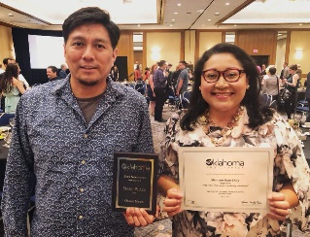
Is it a RESPECTED newspaper? Yes, in addition to having a large readership, since 2008 the Osage News has won numerous awards each year from the Native American Journalists Association, the Oklahoma Press Association and the Society of Professional Journalists - Oklahoma Pro Chapter. Recently it won “Best Newspaper” from the Oklahoma Society for Professional Journalists.
What are the JOBS at the Osage News? Currently, the Osage News has three full-time employees and one independent freelancer.There is an editor who covers the Executive Branch, legal issues and features; a senior reporter, who covers the Osage Nation Congress and boards and commissions; and an editorial assistant/photographer who maintains the Osage News mailing list full-time, assists the editor and takes photos on assignment. The freelancer covers all energy issues and the Osage Minerals Council.
What QUALIFICATIONS must employees have? The Editor must be tribal members, and each employee must have the following education and/or experience:
- Editor - degree in journalism or its equivalent, and at least 5 years of experience in a professional newsroom
- Senior Reporter - a bachelor’s degree in journalism or its equivalent, and at least 2 years’ experience in a professional newsroom
- Photographer and additional staff - at least two years of school at a university or college, or newsroom experience
What TYPES OF INFORMATION does the Osage News publish?
See topics banner under header on www.osagenews.org including the following topics:

- Government - all issues involving executive action, legislation, tribal business, economic development, and financial issues, mineral council issues, and candidate and election news
- Health - services, health care issues, conferences, public health events
- Education - Osage Nation schools, classes, scholarships, conferences, awards
- Culture - news, events, awards relating to Osage history, dance, arts, writing, language, music, Tribal Museum, preserving traditions and stories, profiles of elders
- Legal - Osage Nation legal services, law enforcement, federal agencies, court actions involve Osage Nation, Osage Trial and Supreme Court - no reporting of routine crime and court events such as an “Osage County police blotter”; exceptions include when a criminal event or conviction becomes a legitimate story of interest to readers.
- Services - provided by Osage Nation (i.e. by the many Osage Nation agencies - see “What We Do” tab on www.osagenation-nsn.gov)
- Community Sports - sports-related achievements of Osage Nation members
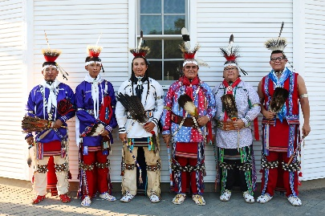
- Notices: family news such as weddings, anniversaries, births, deaths, obituaries (free; info provided by reader)
- Community Calendar - all Osage Nation Events
- Blogs and Columns (monthly articles by same author)
- Editorials - opinion pieces submitted by readers
- Public Service Announcements - published for free
What is the BUSINESS MODEL for the Osage News? How does it earn income & pay expenses? The business model for the Osage News is a yearly appropriation from the Osage Nation Congress, which is supplemented by ad revenue and subscription sales by the Osage News staff.
What are some of the special CHALLENGES of the Osage News? (1) securing a yearly appropriation from the Osage Nation Congress, which is always looking to cut costs. (2) the same problem facing newspapers across the United States: as people obtain more of their news on-line, income from subscriptions will decline.

