OSAGE RANCHING TRADITIONS & BLUESTEM RANCH - FACT SHEET
RANCHING TRADITIONS
After allotment in 1906, many Osage leased the pastures on their allotments to area ranchers.
Others became ranchers and grazed cattle on their own, accumulating additional parcels of land and building up sizeable ranches - aided by their Osage cultural tradition of skilled horsemanship.
The rich tallgrass prairie pastures of the Flint Hills eco-region are famous as some of the best cattle-grazing land in the world (Burns 388).
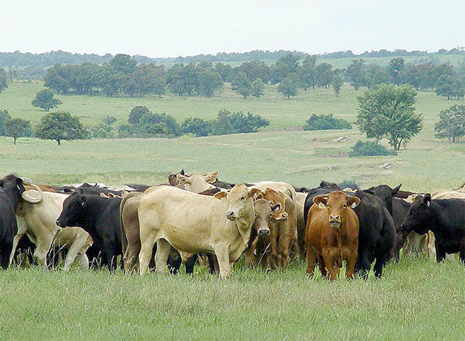
BLUESTEM RANCH - RE-ACQUISITION OF LANDS
The most dominant grass of the tallgrass prairie is the Big Bluestem, and “Bluestem Ranch” is the name of the 43,000 acre ranch in the southern part of the Reservation purchased in 2016 by the Osage Nation.
This purchase is part of the commitment to “bringing back the land to the Osage Nation” - through the re-acquisition (buying back) of some of the 96% of Osage Nation lands lost through allotment and sales.
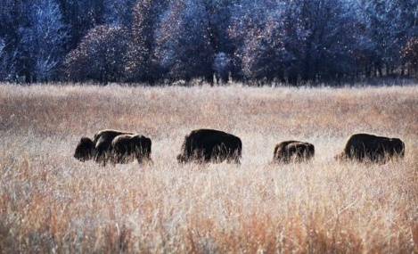
At the Bluestem Ranch dedication, Chief Geoffrey Standing Bear shared his vision of the Bluestem ranch’s potential in the future “as a refuge for our sacred bison, a classroom for our people, especially our young, a place where Osage companies and individuals will conduct profitable cattle operations and a place for well-regulated hunting and fishing recreation” (Polacca, Osage News).
The ranch operation is currently being organized and managed by the Bluestem Board LLC with the mission to create and stimulate the Osage Nation economy, generate profits, and create employment opportunities for tribal members.
The Board states that Bluestem Ranch is part of a “revitalized determination to reclaim its land, and to create a lasting legacy to the tribe’s cultural and agricultural history. Bluestem Ranch is a part of reclaiming the proud past as it seeks to build a successful livestock operation.”
Sources: Burns, Louis F. History of the Osage People. Tuscaloosa: University of Alabama Press, 2004. Polacca, Benny, “Osage Nation Celebrates Purchase of Bluestem Ranch,” Osage News 8-26-2016. Bluestem Ranch webpage: http://www.tallgrass-osage.com/bluestem-ranch-3/ Compiled 2018.

