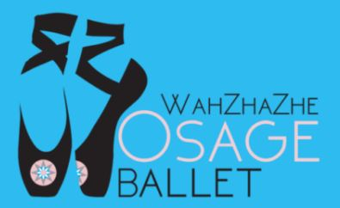
Wahzhazhe: An Osage Ballet - Fact Sheet

What does “Wahzhazhe” mean? Osage. Nee Oh-kah-shkahn is the original Osage word for themselves meaning “Children of the Middle Waters.”
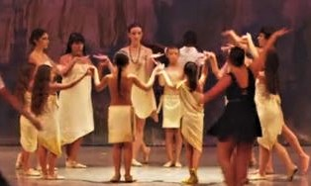
What is the ballet about?
Wahzhazhe: An Osage Ballet provides an inspiring history of the Osage people and culture through the powerful medium of dance and music.

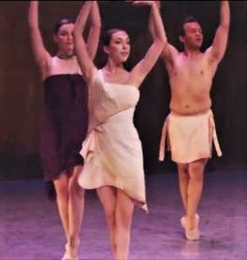
Read “The Story” *- insightful, brief history of the Osage, and informative background on the ten scenes:

Act One
- Morning Prayer
- Royalty of the Plains
- Pre-contact “wedding”
- Treaties
- The Notice (Move from Kansas)
Act Two
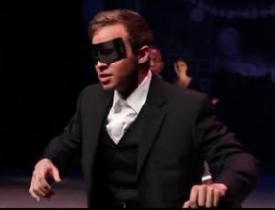
- Boarding School
- Pawhuska Oil
- The Reign of Terror
- Masters of the Battlefield
- We Walk in Two Worlds

What does the ballet look and sound like? You can watch the ballet at*:
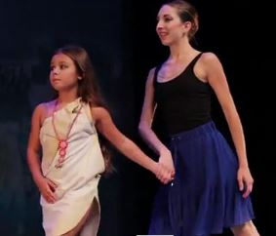
- Osage Ballet Sizzle Reel - 52 seconds of video samples of the ballet’s powerful music, dance, and costuming
- Osage Ballet - video of the entire ballet! - 64 minutes
But it’s best in person: one woman embraced a young dancer after the show, explaining through tears that she had no words for the depth of emotion that she felt after watching the ballet.

Where is it performed?
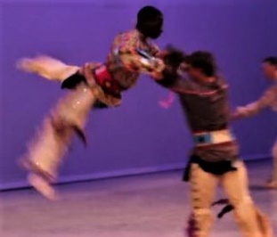
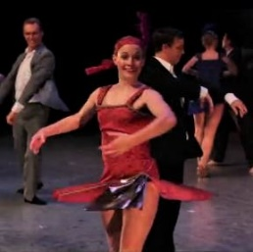
Since 2012, it has been performed by the Osage Ballet company all across the region as well as and at the Lensic Performing Arts Center in Santa Fe, New Mexico, at four days of sold-out performances at the Smithsonian National Museum of the American Indian in Washington, DC., and before a half million people during Pope Francis’ visit at the Philadelphia Festival of Families.

Who created the ballet?

- Ballet Director: Randy Tinker Smith*
- Choreographer: Jenna Smith*
- Artistic Advisor: Roman Jasinski
- Music Composers: Lou Brock* and Dr. Joseph Rivers, Ph.D.
- Music Arranged and Orchestrated by: Dr. Joseph Rivers, Ph.D.
- Costume Designers: Wendy Ponca* and the late Terry Wann*
- Set Designer: Alexandra Ponca Stock*

*members of the Osage Nation
For the inspiring story of how these talented people came together, read Inside Wahzhazhe.
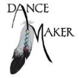
Jenna and Randy Smith also created the Dance Maker Performing Arts Academy which offers dance education opportunities for all young people in Pawhuska and surrounding rural area.

