TALLCHIEFS: OSAGE BALLET LEGENDS - FACT SHEET
ballet - an artistic dance form performed to music using precise, formal set steps and gestures
prima ballerina - chief female dancer in a ballet or ballet company
choreographer - creates dance compositions; plans & arranges dance movements & patterns for dances
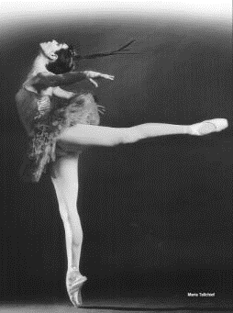
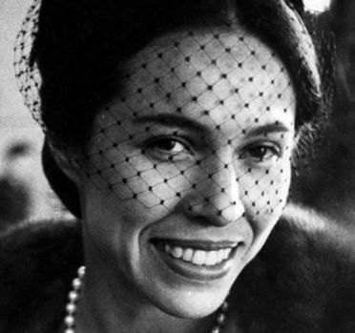
Maria Tallchief (1925-2013)
Maria Tallchief was the oldest of two sisters of Osage descent who became famous ballerinas in the 20th century. Maria was considered America's first major prima ballerina. She was the first Native American to hold the rank.
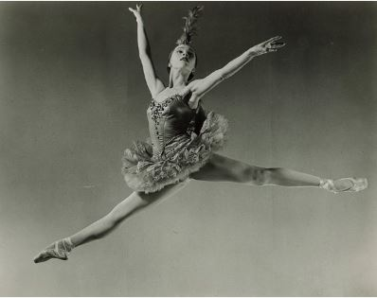
Almost from birth, Maria was involved in dance, starting formal lessons at age three. When she was eight, her family relocated from her birth home of Fairfax, Oklahoma, to Los Angeles, California, to further her ballet and musical training, and provide future career opportunities for her and her younger sister, Marjorie.
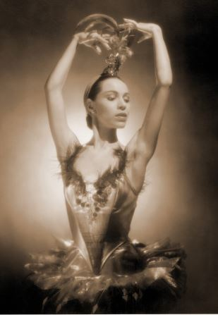
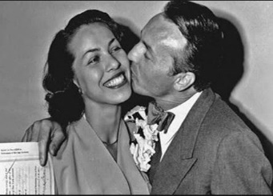
At age 17, she moved to New York City in search of a spot with a major ballet company and took the name Maria Tallchief. She spent the next five years with the Ballet Russe de Monte Carlo, where she met legendary choreographer George Balanchine. Their marriage in 1946 was later annulled, but they remained friends and continued working together as dancer and choreographer.
When Balanchine co-founded what would become the New York City Ballet in 1946, Tallchief became the company's first prima ballerina in 1947, a position she held for 13 years.
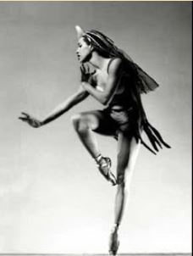
The combination of Balanchine's difficult choreography and Tallchief's passionate dancing revolutionized the ballet. Her 1949 role in The Firebird catapulted Tallchief to the top of the ballet world.
Her role as the Sugarplum Fairy in The Nutcracker transformed that ballet from obscure to America's most popular, establishing it as a Christmas classic. She traveled the world, becoming the first American to perform in Moscow's Bolshoi Theater. She made regular appearances on American TV before she retired in 1966.
In 1956 she married Henry Buzz Paschen. Their daughter Elise Paschen is a prominent American poet.
After retiring from dance, Tallchief was active in promoting ballet in Chicago. She served as director of ballet for the Lyric Opera of Chicago for most of the 1970s, and debuted the Chicago City Ballet in 1981.
Tallchief was honored by the people of Oklahoma with multiple statues and an honorific day. She was inducted in the National Women's Hall of Fame and received a National Medal of Arts. In 1996, Tallchief received a Kennedy Center Honor for lifetime achievements. Her life has been the subject of multiple documentaries and biographies. The Osage tribe named her Princess Wa-Xthe-Thonba, Woman of Two Standards.
One Osage elder said, “Maria Tallchief will always have a special place in Osage history and in the hearts of the Osage people. Her life will always stand as a shining beacon for Osage young people of how dedication to one’s God-given talents can be translated into great artistic achievement.”
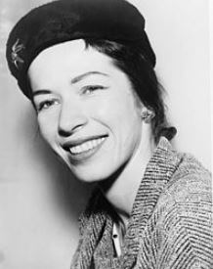
Marjorie Tallchief (1926 - )
Marjorie Tallchief was a ballerina of the Osage Nation and the younger sister of the late prima ballerina, Maria Tallchief. Marjorie was the first Native American to be named "première danseuse étoile" in the Paris Opera Ballet.
Raised in Fairfax, Oklahoma, she moved with her family to Los Angeles, California to further her ballet training.
After working under Ernest Belcher, Bronislava Nijinska, and David Linchine, Tallchief performed with the American Ballet Russe de Monte Carlo, the Grand Ballet du Marquis de Cuevas, Ruth Page's Chicago Opera Ballet, and the Harkness Ballet. Her most acclaimed roles were performed in Night Shadow (1950), Annabel Lee (1951), Idylle (1954), Romeo and Juliet (1955), and Giselle (1957).

Tallchief was married to artistic director, ballet master, and choreographer George Skibine on August 5, 1947 in Vichy, France.
Marjorie Tallchief has served as director of dance for the Civic Ballet Academy in Dallas, Texas, the City Ballet in Chicago, Illinois, and the Harid Conservatory in Boca Raton, Florida, where she remained until her retirement in 1993.
With both classical and contemporary roles, Marjorie was one of the most versatile ballet dancers of the twentieth century. She performed throughout North America and Europe and has danced for many heads of state, including John F. Kennedy, Charles de Gaulle, and Lyndon B. Johnson. Her honors include Oklahoma Hall of Fame and University of Oklahoma distinguished service award.
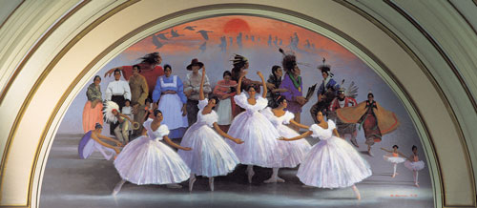
Oklahoma Indian Ballerinas
Maria and Marjorie Tallchief were two of five dancers of Indian heritage, all born at roughly the same time, who achieved prominence in the 20th century, and came to be called the Oklahoma Indian Ballerinas. The others included Rosella Hightower (Choctaw), Moscelyne Larkin (Peoria/Eastern Shawnee), and Yvonne Chouteau (Shawnee). Flight of Spirit mural shown above portrays the five ballerinas. Also see Five Moons, a bronze sculpture in Tulsa, Oklahoma.
SOURCES: Oklahoma Historical Society “Tallchief, Elizabeth Maria” and “Tallchief, Marjorie Louise,” also Wikipedia, also “Maria Tallchief,” “Marjorie Tallchief,” and “Five Moons.”

