Name___________________________________ Seal of the Osage Nation
In 1957, this seal was created and chosen to be the official symbol for the Osage Nation. It was designed by Mr. Romaine Shackelford of Pawhuska, Oklahoma. The Osage Seal appears on official publications of the Osage Nation, and can be used only with special permission.
The seal is created in the round shape of the traditional Osage shield, which not only protected its owner, but also conveyed important messages through the use of symbols.
What symbolic messages are expressed by the objects in the Osage Nation Seal?
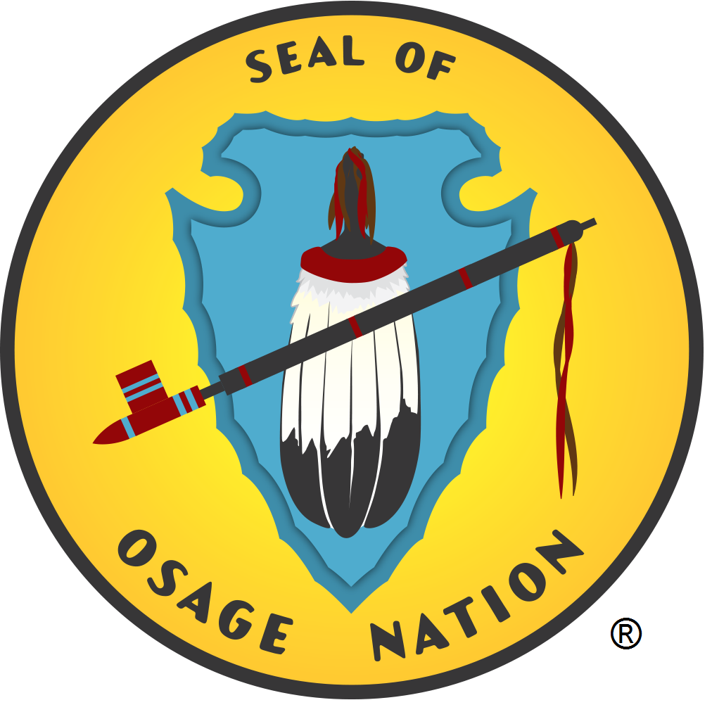
- The background within the circle of the Seal is bright yellow edged in black. This golden circle represents tribal prosperity.
- In the center is a large sky blue arrowhead which points downward. This arrowhead represents the hunt.
- A red sacred pipe crosses the arrowhead and fan diagonally. This sacred pipe represents peace and friendship.
- Centered on the arrowhead is a prayer fan composed of black and white Eagle feathers with a red handle. This eagle feather fan represents tribal authority.
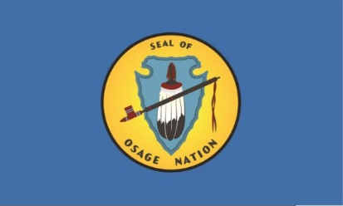
- In the Osage flag, the seal is centered on a light blue background which represents the “Sky People,” one of the Osage clans.
DIRECTIONS: Complete this chart explaining SYMBOLISM in the Osage Seal & Flag
Object or Design | What it symbolizes / represents

