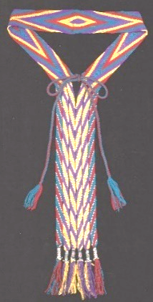
The Art of Osage Finger Weaving - Fact Sheet
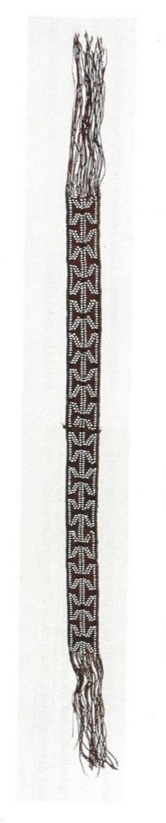
The art of finger weaving produces woven strips without any mechanical devices or tools. It combines indigenous and European influences: an example of an ancient artistic technique given new energy through the introduction of new materials and colors. (Bailey 165)
Very early Osage women used vegetal fibers such as rush and nettle to make mats, bags, and ropes. Buffalo hair - including lighter-colored buffalo calf hair - could be spun into long strands and braided for ropes, bridles and cordage, or used to make long sashes for medicine bundles.
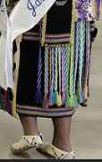
With the fur trade of the 1600’s, colorful commercial yarn was available, greatly expanding design possibilities. Woven sashes became an important trade item. They were also used in traditional dress for both men and women. For women, “a broad finger-woven sash secures the skirt, and smaller woven strips hold the half-leggings in place.” A blouse covers the sash so only the long fringe is visible hanging in the back, which sways when the women dance. The men also wear finger-woven sashes, side-drops, and garters. (Bailey 165-6)
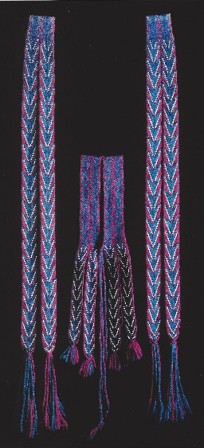
SEE ALSO: LESSON ON TRADITIONAL OSAGE CLOTHING
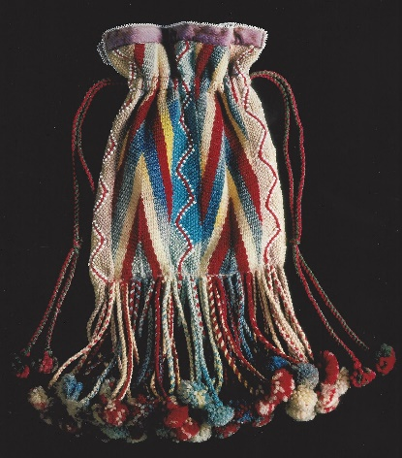
“The revival of interest by the young dancers in recent decades has helped to stimulate and revive the Osage arts of ribbon work and finger weaving essential to the tribal traditional dress. In the late 1960s these were almost lost arts, as very few Osages remained who know them. Maudie Cheshewalla, curator of the Osage Tribal Museum in Pawhuska, Oklahoma, encouraged the revival of ribbon work and finger weaving in the early 1970s by offering classes at the museum through the Emergency Employment Act. She has taught several hundred women the art of finger weaving, and by the late 1980’s women in Pawhuska, Grayhorse, Hominy, and other towns had become well known for their talents in creating the Osage traditional dress for both family members and others.” (Callahan 108)
“According to Maudie Cheshewalla, finger weaving is one of the most religious types of art done by the Osages, because the finger-woven articles are only worn at tribal dance time. Among these finger-woven articles are belts, garters, sacred sashes, and the bags used to carry religious articles. (Callahan 120)
“Even after many years of practice, Maudie Cheshewalla could only work some six hours a day in finger weaving, completing about one inch per hour. A woman’s sash took her about two months to complete. Considered an authority in finger weaving, she had the ability to take an old pattern--even one a hundred years old -- and figure it out. Because of this ability she was often called on by museums to repair or copy some of their unusual and important pieces of finger weaving.” (Callahan 123-4)
Process: “Finger weaving, sometimes known as Osage braid because of the tribe’s extensive use of this craft, is a very old method of thread interlacing in which the fingers pick up the vertical warp threads [the multiple long up-and-down threads] through which the horizontal weft [the single sideways thread that is woven back-and-forth] is passed. The weaving is worked from the center to the outside edges and is a very tight weaving, giving much the same effect as tapestry weaving. (Callahan 121)
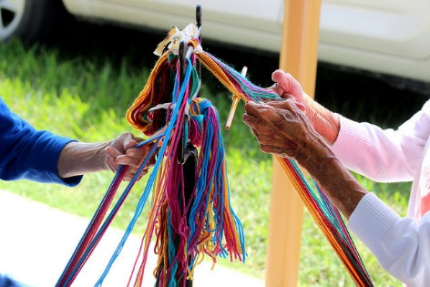
Finger weaving is challenging - combining speed and special attention. The finger weaver must work quickly, but also take care “to ensure that the tension of the individual threads is consistent throughout the thousands of twining movements needed to create a finished piece.” Without consistent tension, the piece will be twisted and won’t lie flat. (Bailey 165-6)
“In earlier times the women sat of the ends of the strands of wool yarn. Today they tie the yarn strands to a solid support such as the back of a chair or a stand. With the development of finger weaving it became possible to weave many new geometric designs for use in ceremonial sashes, garters, and headbands. According to Maudie Cheshewalla [in the 1980’s], the Osages are about the only ones who weave with so many different patterns. They are also the only ones who use beads in their weaving.” (Callahan 121-2)
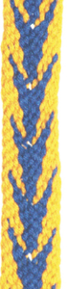
“The debate whether the finger weaving method was aboriginal or introduced, and whether the designs were influenced by European embroidery taught in mission schools or were original designs among the Osages, will probably never be completely resolved. However, the French probably are the sources of such favorite Osage designs as the chevron, the double chevron, and the fleur-de-lis. (Callahan 121-2)
“Other favorite designs, such as the spider, the arrow, the diamond, and the double diamond, are probably Osage in origin. The Osage tribe alone uses the double diamond in its finger weaving. These last designs appeared as motifs on Osage tents, costumes, and artifacts from before the Europeans’ arrival. It is believed that the Osage simply transferred the older motifs to the new materials and crafts, such as ribbon work, which came with the Europeans.” (Callahan 122-3).
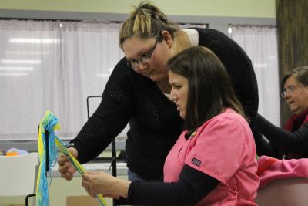
Osage finger-weaver Julia Lookout (wife of Chief Fred Lookout) taught Anita West, who taught Wah-Zha-Zhi Cultural Center director Addie Hudgins. In the finger weaving classes today, Hudgins and other instructors helps students through the entire process of their project. She helps students pick colors, get set-up then teaches them the basic designs of finger weaving. These classes help ensure the future of finger weaving in Osage traditional art. (Osage News, April 23, 2013)
Sources: Bailey, Garrick Alan and Daniel C. Swan, John W. Nunley, and E. Sean Standing Bear. Art of the Osage. Seattle: St. Louis Art Museum in association with University of Washington Press, 2004. Callahan, Alice Anne. The Osage Ceremonial Dance: I’n-Lon-Schka. (Norman, OK: University of Oklahoma Press, 1990). Duty, Shannon Shaw, Osage News 10-21-2009 and April 23, 2013. Compiled 2018.

