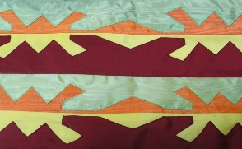
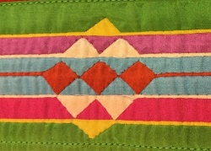
OSAGE RIBBONWORK - FACT SHEET
Ribbonwork is the cutting and sewing of ribbons into geometric patterns.
The story of ribbonwork starts when the Osage first had contact with French in 1673. At this time, the Osage were a semi-nomadic people living south and west of Missouri River. They soon became strong allies and trading partners with the French, exchanging furs for trade goods from Europe - including colorful satin ribbon. Ribbon had been used in France for lacing, ties and hair fashions of the wealthy, but after the French Revolution overthrew the rich aristocrats, ribbon became unpopular in France. The French were happy to trade leftover ribbon to the Osage.
The Osage, like many Indigenous peoples, adapted ribbon and other European tools and materials to fit their needs in new and different ways. For example, the Osage, along with other Native American communities, used the new ribbon, thread, scissors and needles to develop the new art of ribbonwork as a way to decorate their clothing.
Other Plains tribes (Pottawatomie, Sac & Fox, Omaha and Winnebago) also practiced ribbonwork, but each tribe has its own style. Osage ribbonwork is unique and tells the Osage story over time through its changes in style and level of complexity.
To begin, many Osage used colors symbolically. For example, some ribbonwork artists would use light and dark colors to symbolize balance in the life of the person wearing the ribbonwork. [See - “Symbolism Motifs Color in Osage Art-List”]
Osage and other ribbonwork artists developed two main styles of ribbonwork:
Four strip or Overlay Pattern Stripped Ribbon Pattern
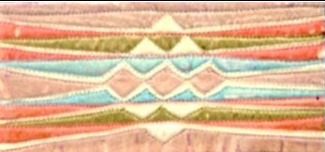
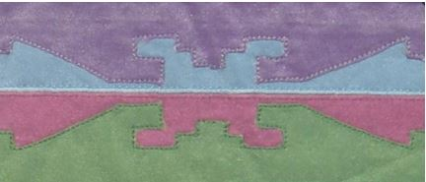

Ribbonwork almost died out as an art form around the 1920’s. Around this time, there was a great deal of change within Osage social and cultural practices. Modern clothes replaced traditional clothes which were worn only for special events. However, the In-lon-schka dance tradition continued on a small scale, and it helped keep the art of ribbonwork alive.
Georgeann Robinson was a traditional artist who was devoted to preserving and developing ribbonwork. In the 1950’s, only three women in the tribe still knew how to do ribbonwork. Georgeann and her sisters Louise and Genevieve began to research the art. They taught themselves more about it, and opened a store in which they offered custom-made ribbonwork art. Soon, in the 1960’s and 1970’s, there was revival of interest in Osage traditions and clothing.
In this period, Robinson continued to develop her ribbonwork from a “craft” into a uniquely individual “art.” See Robinson biography and video (3 min).
Robinson’s daughter Jan Jacobs and others made sure the tradition continued. See also video of ribbonworker Jan Jacobs in which Jacobs tells about the history of ribbonwork, how she became involved with her mother, and demonstrates some of the process. Followup-up video also includes additional interview footage of Gerogeann Robinson.
Robinson’s granddaughter, Jami Powell, is an anthropologist and museum curator who writes scholarly articles and helps lead research on the history, importance and process of ribbonwork. See Finding Our Way. (An anthropologist studies the cultures of human groups: anthro means human).
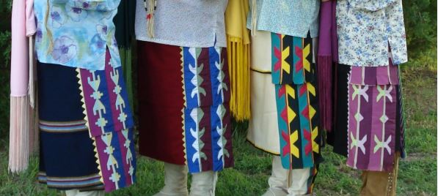
During the latter decades of the 1900’s, the In-lon-schka dances grew in size and participation, and traditional clothing displaying ribbonwork again became an integral element of Osage culture. Powell writes, “When wearing traditional dress, as did one’s ancestors, a person is able to connect with their heritage and past in a very special way.” (at right, women’s skirts with 4-strip ribbonwork pattern)
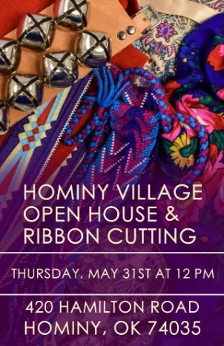
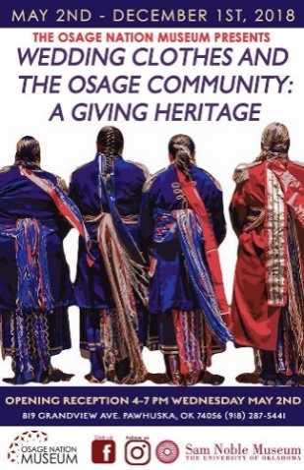
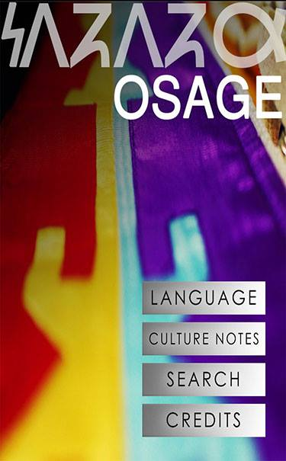
Today, ribbonwork patterns have become symbolic of Osage culture, and appear in Osage art in homes, on jewelry, and in Osage Nation graphic design (at left).
Osage ribbonwork is now a respected art form displayed in museums and collections. It has even become part of the Folk and Traditional Art award of the Smithsonian.
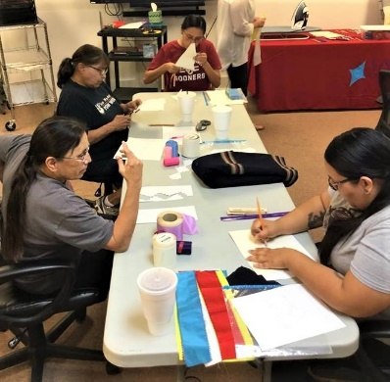
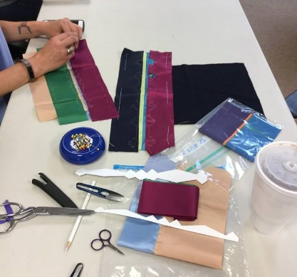
Today, the Osage Nation Museum is gathering documentation about historical and contemporary Osage ribbon work practices for future generations. Also, Osage are taking classes through the Wah-Zha-Zhi Cultural Center to learn how to create ribbonwork.
All are working together to continue this beautiful artistic tradition of the Osage.
Sources: Powell, Jami. “Finding Our Way: Osage Ribbonwork and Revival.” Lambda Alpha Journal, Volume 39, 2009, pp 12-22. National Endowment for Arts Fellow 1982 Georgeann Robinson. Master of Traditional Arts Georgeann Robinson. Denver Art Museum Native Artist-in-Residence Jan Jacobs. Compiled 2018.

