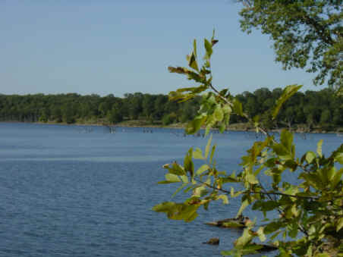
OSAGE LANGUAGE PLACE NAMES - FACT SHEET
- Big Hill Creek, Kansas (waterway) - flowing into the Verdigris above Coffeyville; named for the Big Hill Band of Osages called Pa Sole’ - sitters on hilltops - from story of escape from flood (p. 118) Also Big Hill Lake.
- Big Hill, Kansas (town) in Labette County - see above Big Hill Creek (p. 118 see above Big Hill Creek)
- Caney River, Kansas & Oklahoma (waterway) - translated from Osage name Mur-sho meaning stream with luxuriant cane growth (p. 137)
- Chetopa Townships, Kansas (county sub-division) in Neosho, Wilson, and Montgomery Counties, Kansas - (p. 117 see below Chetopa, KS)
- Chetopa, Kansas (town) in Labette County - named for a friendly Osage chief who was given a commission in the Union Army to command an Indian regiment during Civil War (p. 117)
- Chingawassa Springs, Kansas (waterway) - near Marion, KS, named for Osage Chief Shingawassa; the Marion Belt and Chingawassa Springs Railroad brought picnickers and health-seekers to this spa (p. 120)
- Claremore, Oklahoma (town) in Rogers, County - named for Osage Chief Claremont, chief of the Little Osages (p. 121)
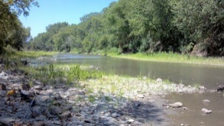
- Marais des Cygnes River, Kansas (waterway) - Osage called junction of the two Grand and Little Osage rivers Mi’xa-ckau-tse as “where white swans are plentiful” (Osage word for swan -). French translated this into “Marais des Cygnes” or marsh of swans (p. 111). In an unusual situation, on the Kansas side, the river is called Marais des Cygnes, but on the Missouri side, it is called the Osage River (see below Osage River).
- Neodesha, Kansas (town) - in Wilson County - from Osage word ni-o-sho-de - meaning “sweetly flowing” (p. 136)
- Neodesha, Oklahoma (town) in Wagoner County - see above Neodesha, KS (p. 136)
- Neosho County, Kansas (county) - (p. 131 see below Neosho River)
- Neosho Falls, Kansas (town) in Woodson County (p. 131) - (see below Neosho River)
- Neosho Rapids, Kansas (town) in Lyon County (p. 131) - (see below Neosho River)
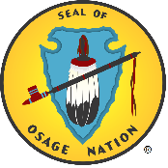
- Neosho River in Kansas & Oklahoma (waterway) - from Osage word o-sho’de meaning “smokelike appearance of water when the soft mud on the bottom is stirred” or from Nion-Chou name of Great Osage village across the river, also from Osage word with Siouan or Lakota meaning of ne or ni for “water” (128)
- Osage Nation (tribal name) - derived from French pronunciation of Osage term Wah-Zha-Zhi - “children of the Middle Waters” (became Ouazhaghi, Ozazge, eventually Osage) (p. 109)
- Osage City, Kansas (town) - county seat of Osage County, Kansas (see above Osage p. 113)
- Osage County, Kansas (county) (see above Osage p. 113)
- Osage County, Oklahoma (county) - This is the area of the Osage Nation Reservation. (see above Osage p. 113).
- Osage River, Missouri (waterway) - named by explorer Charles Claude du Tisne “Riviere des Osages” (see above Osage p. 113)
(a) Grande Osage River, Missouri (waterway) - north fork settled by Big Osage band (p. 111)
(b) Little Osage River, Missouri (waterway) - southern fork settled by Little Osage band (p. 111)
- Osage Townships, Kansas (county subdivision) - in four Kansas counties: Bourbon, Crawford, Labette, and Allen (see above Osage p. 113)
- Osawatomie, Kansas (town) in Miami County - combination of two river names: Osage and Potawatomie (p. 123)
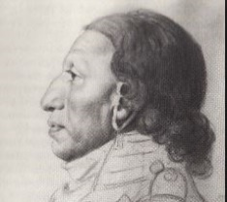
- Owasso, Oklahoma (town) in Rogers & Tulsa Counties - named from Osage word Owasso, meaning "the end of the trail" or "turn around” because the rail line ended in a turnaround there. (http://www.okhistory.org/publications/enc/entry.php?entry=OW001)
- Pawhuska, Oklahoma (town) in Osage County - named for Chief Paw-Hiu-Skah (meaning “White Hair”). Chief White Hair got his name not from having white hair but from an incident in the War of 1812 when he grabbed for a scalp lock and found instead a white wig in his hand. He put the wig on his head and frequently wore it thereafter (p. 116. This is Osage Nation’s headquarters, and County Seat of Osage County.
- Pumpkin Creek, Kansas (waterway) - flows into Verdigris from East near Coffeyville - named for Osage word Watunk-a-kashink meaning “pumpkin” (p. 134)
- St. Paul, Kansas (town) in Neosho County - originally called Osage Mission, later changed to St. Paul in honor of Father Paul Ponziglione served the Osage at this mission from 1852-1889 and was much respected by the Osage (p. 114) (Louis Burns, History of the Osage People, p. 235)
- Turkey Creek, Kansas (waterway) near Chetopa, named for Osage word Su-ka-tuk meaning “turkey” (p. 133-4)
- Verdigris River in Kansas and Oklahoma (waterway) - derived from French translation of words “green” and “gray” from Osage name Wa-Ce-Ton-Xo-E meaning “gray-green-bark-waters” (p. 133)
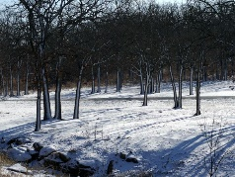
- Wah-Sha-She Park, Oklahoma (park) formerly named Wah-Sha-She State Park, is on the shore of Hulah Lake (Oklahoma) in Osage County, Oklahoma. The name is from the Osage language, meaning “children of the Middle Waters," also “the water people."
- Wichita Falls, Texas (town) - (see above Wichita) (pp 164-5)
- Wichita Mountains, Oklahoma (landform) - (see above Wichita) (pp 164-5)
- Wichita, Kansas (town - large city) in Sedgwick County - derived from Osage words such as Wi-tzi-ta meaning “lodges of faraway people,” “scattered lodges” and “dwellers in reed wigwams” to describing Caddoan people now known as Wichita, who lived in distinctive grass lodges (pp 164-5)

SOURCES: Rydjord, John. Indian Place-Names: Their origin, evolution, and meanings. Norman, OK: University of Oklahoma Press, 1968. Compiled 2018.

