FUN WITH OSAGE LANGUAGE APP - GUIDE
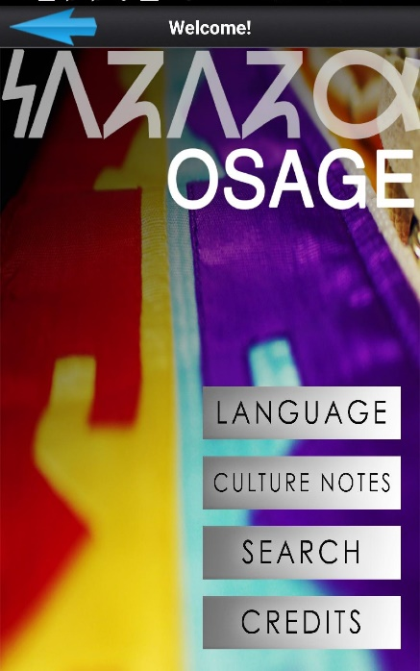
HEAR the Osage Language - Learn to Say Words - Play Games!
HOW TO DOWNLOAD to Android and Apple devices:
- Connect your Android or Apple device to Wifi
- Search “WahZhaZhe” at the Play Store or the App Store on an Android or Apple device
- Find the App option with the Osage seal icon and select
- Select "Install" to download the App

HOW TO USE
The application is approximately 375 MB that requires a wifi connection. After it is downloaded to a device it will not require a data connection unless an update is required.

The language app home screen contains buttons for Language, Culture Notes, Search, and Credits.
Language – (category options: Learn, Games, Quizzes) The Language tab contains approximately 526 words and phrases which are separated into 33 categories.
- Listen & Learn: Each category allows users to learn the language by listening to a word or phrase, reading the orthography, and self-recording for playback and audio learning.
- Play Games: these increase in intensity from easy to hard.
- Test Yourself: After familiarizing with the words and phrases contained in each category there are corresponding quizzes to self-test. Quizzes test listening, speaking, and reading skills.
Culture Notes – (category options: Audio, Video, Images) The Culture Notes tab contains approximately 15 files. Users can
- Listen to a real Osage language Speech delivered in June 1965 by an Osage elder
- Learn the Counting Song
- Access Map of Osage ancestral territories
- Zoom-in on Images - the maps and paintings - view by tapping on the photos in the Images category

Search –Search for any entry via the Search tab.
- Tap “Search” and you will be directed to an alphabetized list of all entries contained within the app
- Scroll through the list or type a specific word or phrase

