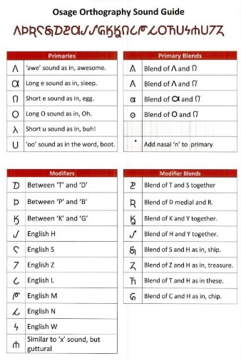
Developing an Osage Orthography - FACT SHEET See also: Osage Orthography Sound Guide
BACKGROUND VOCABULARY
linguist - a person who studies language and its structure
orthography - a system of writing a language
alphabet - the set of orthographic units - letters or symbols in a fixed order, used to represent the basic sounds of a language
character - A written or printed symbol, or letter
phoneme - units of sound in a language that distinguish one word from another, for example p, b, d, and t in the English words pad, pat, bad, and bat.
Unicode - an international encoding standard for use with different languages where each letter is given a number. Since computers just deal with numbers, before Unicode was invented, there were hundreds of conflicting encoding systems, so files were incompatible. With Unicode, each letter, digit, or symbol is assigned a unique numeric value that applies across different platforms and programs. This way, computers can clearly tell what the character should be.

Decision to Save the Osage Language

In 2003, the Osage nation passed a resolution to develop the Osage Language Program to help insure the survival of the language which is such an integral part of Osage culture.
Herman Mongrain “Mogri” Lookout was hired to become the Language Program Director. Lookout had grown up learning Osage by listening to his parents and grandparents. He took for granted the language would always be spoken. However, now that it was dying out, he made it his mission to save the Osage language.
Developing an Osage Orthography
One of the main challenges was that no standard (agreed-upon) orthography (system of writing Osage) existed. Osage was a “spell it how you hear it” language, meaning everyone had their own ways of writing Osage, leading to inconsistency and confusion.
Mogri Lookout being thanked in 2015 for his role in developing Osage orthography and preserving the Osage language.
In 2006, Mr. Lookout began working with advanced learners and elders to create a solution to this problem. By listening to recordings of elders from the 1950s, 60s and 70s, they worked to develop the first specifically-Osage orthography and language database.
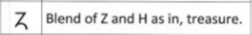
They needed to identify and include all the phonemes (sounds and blends of sounds) that couldn’t be obtained by using the English alphabet. Lookout has said one of the things he likes about the Osage orthography is that it is dedicated to Osage sounds, but is based on the English alphabet, making it easier to learn.
With the help of some linguists and native Osage speakers, a few revisions were made, finalizing the 36-character Osage orthography, which was officially adopted by the Osage Nation in 2015. See: Osage Orthography Sound Guide.
Unicode - International Standard for language symbols
The next step was for the Osage orthography to be accepted by the Unicode international standard for symbols, so it could be accessed from anywhere in the world, on any computer operating system. (Before acceptance into Unicode, it would only appear as boxes and wouldn’t work with many software applications.)
In 2014, the Osage orthography was approved by the Unicode Consortium, and in 2016, it appeared in the Unicode 9.0 system - a historic achievement.
Osage Font and Osage Language App
Being part of Unicode enabled development of the Osage font for computers and the Osage Language App released in 2017. See “Fun with Osage Language App” Guide. With many Osage living in different states, all of this communication through technology is especially important; all can now communicate and learn together on-line.
Dreams to Reality
Going from an idea in 2003 to becoming an internationally recognized font in 2016, the development of Osage orthography has come a long ways. Through the hard work and determination of many, this accomplishment helps fulfill the dream of Mogri Lookout who says: “I want this language to go on forever.”
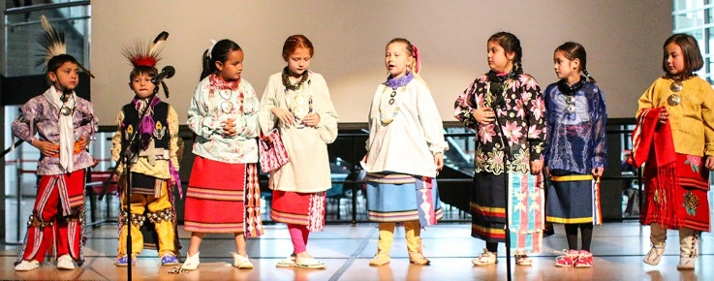
Osage Language Immersion School first grade students competing in the Oklahoma Native American Youth Language Fair

Sources: Polaca, Benny. “Congress recognizes Lookout for Osage language preservation efforts.” Osage News 9-22-15. Shaw Duty, Shannnon. “Osage orthography included in Unicode 9.0, Language Department developing app.” Osage News 7-1-2016. Osage Language Department Font & App page. Photos courtesy Osage News. Compiled 2018.

