WHY SAVE A LANGUAGE? - FACT SHEET
More than half of the 300 indigenous languages of the continent are now extinct. The Osage was almost lost, too.
- HOW WERE INDIGENOUS LANGUAGES LOST?
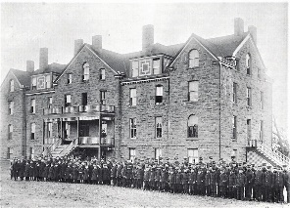
BOARDING SCHOOLS: Suppression of language occurred in early day Mission, government boarding, residential schools. To force students to learn English, they were punished for speaking their native language.
Taking away language is “a human rights violation - not be allowed to talk about your spirit and mental thoughts as one.”- Jesse Taken Alive (Lakota)
FAMILY EFFORTS TO ASSIMILATE: “My great-grandmother passed away in 1940 and my uncle who became the head of the family said that he’d made a decision and told the rest of them - my mother being one - that they would no longer speak the language to us because he was afraid it would bother us in the white man’s world.” Jerry Shaw (Osage)
“To communicate in the white world was made most important.” - Shasta Mandan (Hidatsa)
SPEAK ENGLISH OR GO: “Our languages were literally broken in pieces and scattered. Erasing our native languages, as well as the erasing the European and other immigrant languages followed the philosophy of a monolingual America - idea of ‘speak English or go’ [back to your own country.] And yet we are from here, so we have nowhere to go.” Darrell Kip (Pikuni)
- FIVE REASONS WHY LANGUAGES MATTER:

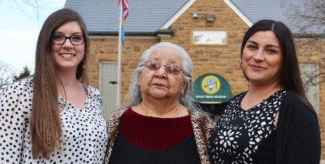
- Languages shape and reflect cultural identity
“The language identifies who we are.” - Darrell Kip (Pikuni).
“The creator gave us in the beginning in our lives, like a gift to us from him, like he gave every animal their own unique song, we also had our own unique sound.” - Kathleen Gordon (Cayuse Walla-Walla)
“What is going to help us survive? Language preservation. Indian languages contain that within them that hope - not to give up.” - Linda Juneau (Pikuni)
“My mother used to say: I can’t tell you what this word means in English because it means so much more.”- Martha Franklin (Yakama)
“The words in our language “were given to us, not only to communicate, but to communicate with a higher power.” - Malcom Wolf (Mandan-Hidatsa)
“You experience something in a special way because of the language. Once a story is passed on to you, in your own language, it becomes yours. You own it. You can’t lose it.” - Narcisse Blood (Kainai)
“Language is a blueprint for thinking - how we experience the world.” - Darrell Kip (Pikuni)
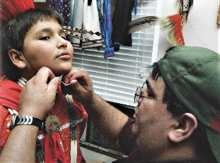
Language is part of traditional identity. Some children don’t know their identity. “They’re ‘cultural blanks.’ But children who grow up with a traditional background with traditional parents, they know who they are, they seem to succeed in life. They seem very respectful, they seem to try to help put the culture back.” (Blackfoot)_________
See OSAGE CULTURAL GLOSSARY and ORIGINS OF OSAGE LANGUAGE
- Native Languages are storehouses of environmental knowledge.
“Because we are in our homeland, our language has had a long relationship with the environment, and grown out of our relationship with the land.” - Darrell Kip (Pikuni)
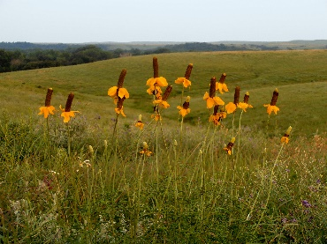
”Our language is a reflection of the ecosystem. The names of things are actually stories. Every person has a story, and the story is how they got their name [unique given Indian names]. You can’t take the name in isolation. You take the story, and the landscape, and the ecosystem, the whole together. You can’t break those connections, or you have disrupted our culture even further.” - Bobbie Conner, Cayuse-Nez Peirce
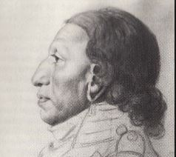
- Indian names and stories give life & meaning to the world.
[See related Osage Language Lesson - OSAGE PLACE NAMES]
“Couer d’Alene name for Mt. Baldy means I’’m sitting by the water.’” - Felix Aripa., Couer A’alene
“Place names tell about the people and place at the time.” Jamie Valadez - Elwah Khallam
“Intelligent people do not burn down libraries. Languages are enormous libraries - contain all the accumulated knowledge of this tribe over thousands of years. Why would we not want to preserve this? Languages are the repository of tribal thought, botany, genesis, philosophy, humor, you-name-it. And they require care.” - Darrell Kip (Pikuni)
- Revitalization of native languages revitalizes native culture
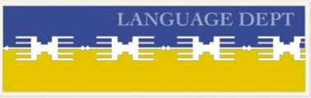
“As we renegotiate the last 200 years, we have to fix those languages that were broken. Elders who teach language connect with younger people.” - Darrell Kip (Pikuni)
See OSAGE LANGUAGE DEPT PROGRAM- https://www.osagenation-nsn.gov/who-we-are/language-department
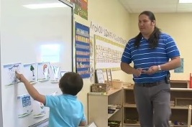
- It helps native students understand all languages better
“Learning our languages helps our children learn the English language better. They do better in English. They read better. They pronounce better.” - Valerie Switzler (Wasco)

SOURCES: Quotes from VIDEO “Why Save a Language” (2006 - 30 min) Producer Salle Thompson Phd. Info compiled 2018.

