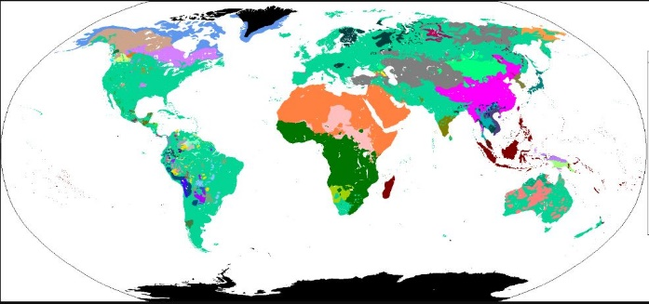
OSAGE LANGUAGE ORIGINS - Fact Sheet
Language Families of the World
Just as our experiences as humans change greatly over time, the languages we speak are also constantly changing and evolving.
The scientific study of our language - its form and meaning - is called linguistics. The study of how language changes over time is called historical linguistics.
Another way to study history is through archaeology - the study of human’s past, often through excavation of sites and analysis of artifacts and physical remains - also called “material” culture.
Linguists and archaeologists are working together to reconstruct the pre-history of the Osage.
They study how the Osage language developed, and how it fits in with others - its language family.
A language family is a group of languages related through descent (being handed down) from a common ancestral language or parental language, called the proto-language of that family. (Proto means the original or first of something, i.e. proto-language).
The division of a proto-language into daughter languages typically occurs through geographical separation (when people separate and some move to a new region or place).
For example: BELOW is the family tree of the English Language.
- Where is English? (it is small - search closely until you see it)
- What is the original (very top) parent or proto-language of English?
- Notice how the subdivisions tend to be grouped geographically: related languages are often near each other on a map. What country in Europe speaks the language English comes from?
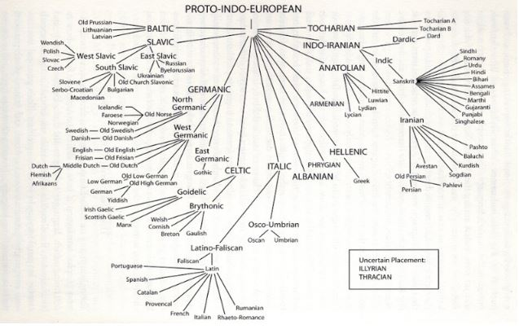

BELOW is the family tree of the Osage language.
- What is its original parent or proto-language?
- Where is the Osage language?
- Notice how the subdivisions are grouped geographically, and sometimes follow major river valleys: Missouri River, Mississippi River, and Ohio River.
- On this Siouan family tree, Osage is closely linked to the Kansa (Kaw) language. This shows they are closely-related and are mutually intelligible - meaning speakers can understand each other pretty well.
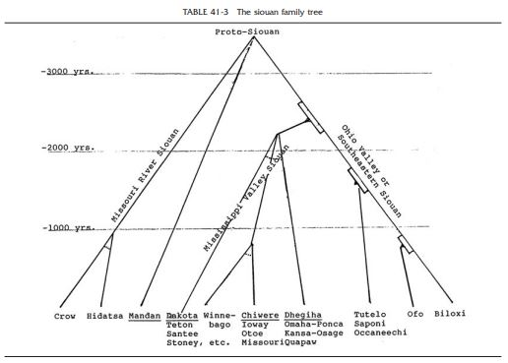
Geographical history: Here is what we have learned about the geography of the five groups in the Dhegiha language branch of the Mississippi Valley Siouan division:
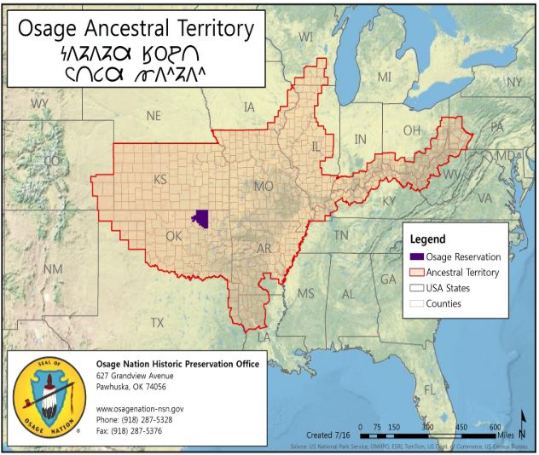
- All five of these tribes were together in the Ohio River Valley. Around A.D. 200-400, they all began migrating down the valley to the confluence of the Mississippi and Ohio Rivers.
- In A.D. 900, four tribes (less the Quapaw) created large settlements around what is now the St. Louis area.
- Around A.D.1000, the Omaha and Ponca tribes separated and moved on.
- Around A.D. 1200, the Kansa (Kaw) separated and traveled up the Missouri. Today, the Kaw and Osage languages are very closely related - .
- The Osage were the last remaining Dhegiha Siouan tribe in the St. Louis area. Around 1350, they moved westward into central and western Missouri. See related lesson: Ancestral Lands.

Sources: Hunter, Andrea A., “Ancestral Osage Geography,” Osage Nation Historic Preservation Office webpage - https://www.osagenation-nsn.gov/who-we-are/historic-preservation/osage-cultural-history; Rankin, Robert L., “Siouan Tribal Contacts and Dispersions Evidenced in the Terminology for Maize and Other Cultigens,” pp. 563-575 in The History of Maize, ed. Staller, John E. et al (Walnut Creek, CA: Left Coast Press, Inc., 2009). Compiled 2018.

