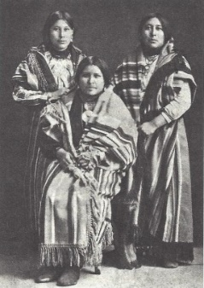
Reign of Terror: the Osage Indian Murders Fact Sheet
Source of Wealth: Reserved Mineral Rights
When the Osages had to give up their communal (co-ownership) of land under the Osage Allotment Act of 1906, Chief James Bigheart wisely insisted that the Osage keep communal ownership of their mineral rights (the right to mine or produce underground minerals such as oil, gas, and rocks), so these rights could not be sold or lost. As a result, all tribespeople at the time were listed on the allotment roll, and given a “headright” - right to a share of mineral interest (oil) income - distributed in regular payments called royalties. Headrights could be inherited - passed on from generation to generation. See Lesson: Osage Lands - 1872 to Today
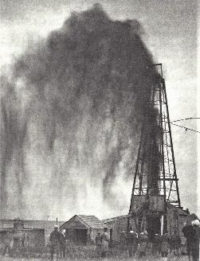
Oil Boom - Million Dollar Elm
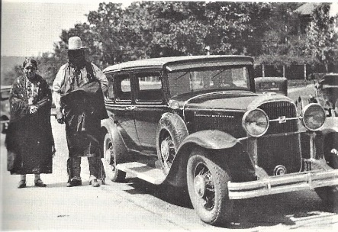
When oil was discovered, reserving the minerals resulted in the Osage becoming some of the wealthiest people in America from royalties received during the 1920’s peak production - able to buy cars and nice homes. Tens of thousands of oil workers flooded into the area, and over 30 boom towns sprang up. By 1923, there were 8,579 oil wells on the Osage reservation, netting $27 million a year. Oil and gas leases (giving access to property to drill for oil and gas) were auctioned for millions of dollars beneath the “Million Dollar Elm” in Pawhuska. The Osage oil fields were among the largest in the world.
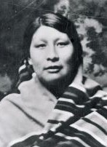
License to Steal - Corrupt Guardians
All this also attracted white entrepreneurs and opportunists to Osage County, some with criminal intent to steal from the Osage. Supposedly to “protect” the Osage who were inexperienced with all this new wealth, the U. S. government passed a new law whereby guardians - local white lawyers or businessmen - would manage the Osages’ money for them. The ward (Osage person) received a minimal allowance to live on while the guardians received a substantial fee and controlled the rest of the money.
Though some guardians were honest and sincere, this arrangement created a huge incentive for corruption - motivation for the guardians to use their position for dishonest, criminal purposes. This included not only embezzlement or taking of their ward’s money, but also actual transfer of headrights through fraud (deception, trickery). For example, sometimes the Osages’ living allowances were so low, they had to “borrow” from their guardians, becoming trapped in debt and forced to give up assets far in excess of their debts. The Osage lost millions of dollars. Only two dozen guardians were ever charged with corruption, and even these avoided punishment by settling out of court.

Murders - the Reign of Terror
However, immeasurably more sinister were actual murders of Osage people in order to inherit their headrights, life insurance, or other assets. With horrifying frequency in the 1920’s, highly unusual numbers of otherwise healthy Osage people were dying in unexplained, suspicious deaths. However, the coroner’s office falsified death certificates, i.e. claiming suicides of people had been poisoned.
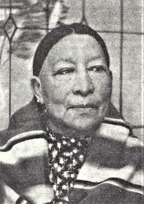
For example, the death of Osage writer Dennis McAuliffe’s grandmother Sybil Bolton at age 21 in 1925 was first blamed on kidney disease, then suicide. McAuliffe much later learned her murder had been covered up by a false death certificate. He suspects his white step-grandfather who had been appointed to be her guardian, and guardian of four other Osages - each of whom had died by 1923. (See Dennis McAuliffe’s The Deaths of Sybil Bolton.)
The case made famous by David Grann’s The Killers of the Flower Moon involved the plot by local businessman William Hale (shown below) and his nephew to murder his nephew’s own wife Mollie Burkhart and her family through poisoning, bombing, and shooting - in order to inherit their headrights. Mollie (shown at left) survived.
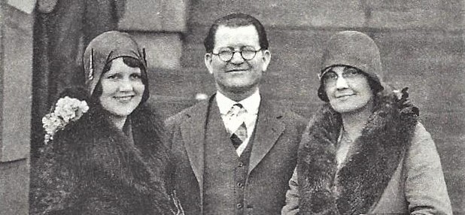
Lack of Justice
William Hale with his wife and daughter
Despite the obviously unnatural number of deaths, due to collusion and bribery (payoffs) among local officials, police failed to investigate most murders and no one was prosecuted. David Grann writes, “Countless lawmen and prosecutors and judges had a hand in the blood money.”
A few brave white citizens tried to stand up to the criminals, but they received death threats, and some were killed. For example, attorney W. W. Vaughn was murdered - thrown from a train - to prevent him from testifying about the conspiracies.
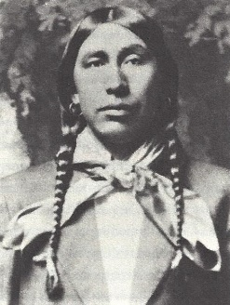
The Reign of Terror, as some newspapers called it, continued. Estimates of the numbers murdered range from 25 to well into the hundreds during this period. Osage historian Louis Burns stated, “I don’t know of a single Osage family which didn’t lose at least one family member because of the headrights.”
Finally, Osage tribal officials received help from the outside: the newly-formed Federal Bureau of Investigation (FBI). After huge efforts, the FBI finally secured the conviction of William Hale and his accomplice, John Ramsey. Ramsey confessed to participation in the murder of Henry Roan (shown at left). (After a series of loans from Hale, Roan had listed Hale on his $25,000 life insurance policy.)
The Reign of Terror was one of the darkest eras of Osage history - a cautionary tale of the extent of evil that can be spawned by greed and depravity. White people killing Osage who were their own family members just for their money was beyond belief. Overall, shocked, frightened, and dispirited, many Osage left Oklahoma during this era - creating a diaspora or scattering of the tribe.
SOURCES: Burns, Louis F. History of the Osage People. Tuscaloosa: University of Alabama Press, 2004. Grann, David Killers of the Flower Moon: The Osage Murders and the Birth of the FBI. New York: Doubleday, 2017. Jon D. May, "Osage Murders," The Encyclopedia of Oklahoma History and Culture, www.okhistory.org (2018). Encyclopedia. McAuliffe, Dennis, The Deaths of Sybil Bolton: An American History. New York: Times Books, 1994. Compiled 2018.

