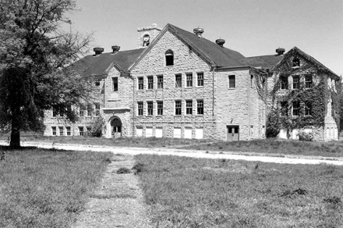
CHILOCCO INDIAN SCHOOL - FACT SHEET + SONG & ART
Many Osage attended boarding schools on the reservation: St. John’s for boys and St. Louis for girls. However, others went to school off the reservation federal Indian boarding schools.
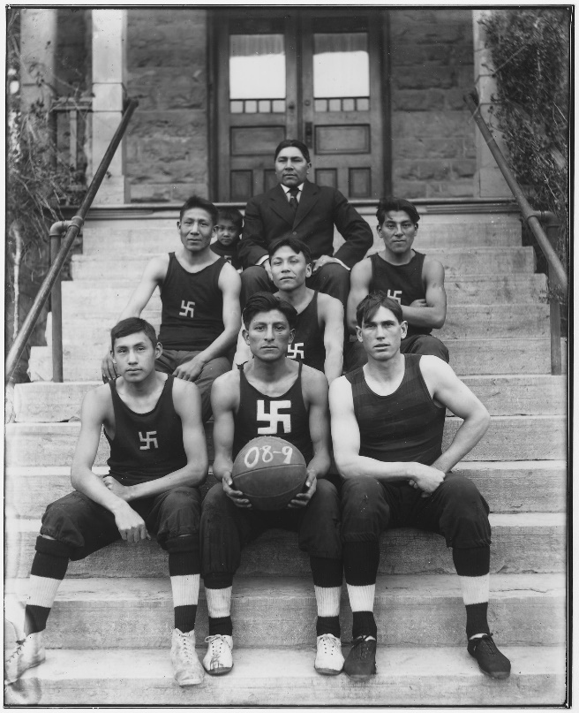
Some Osage attended the closest federal school, Chilocco. Located in the remote prairie near the Kansas border north of Ponca City, Oklahoma, Chilocco Indian School operated from 1884 to 1980.
The 1909 Chilocco basketball team. Chilocco teams often defeated university teams. The swastika was an ancient symbol in many Native American cultures, commonly used before World War II.
The goals of these schools were to dissolve tribal identity and erase indigenous (Native American) beliefs, practices, and languages. Their methods were forced separation of children from their parents and strict military-style rules (uniforms, marching, etc.)
At Chilocco’s height, 1200 students lived and learned in 35 buildings on 8640 acres. In total, over 18,000 students from 126 tribes attended Chilocco, which was sometimes called “Prairie Light.”
Despite being lonely and discouraged, students also remember with pride the love and mutual support which bound them together, the creation of new pan-Indian (across tribal lines; “pan” means across) identities, and reinforcement of old tribal bonds.
For more info:
Book: Tsianina Lomawaima, They Called it Prairie Light: The Story of Chilocco Indian School (Lincoln: University of Nebraska Press, 1994).
Chilocco Indian School Wikipedia
Abandoned Oklahoma - Chilocco Indian School - history and description of the school, with personal accounts of experiences by former students
K. Tsianina Lomawaima, "Chilocco Indian Agricultural School,” The Encyclopedia of Oklahoma History and Culture, www.okhistory.org (accessed May 18, 2018). At Print book: K.
Video: Chilocco Indian School 1932-1942 (30 min) un-narrated film footage of students & activities 1932-42

Song and Art Interpreting Boarding School Experience at Chilocco
Potawatomi singer-songwriter Elexa Dawson grew up hearing the stories of her great-grandmother, one of the students who attended Chilocco. Dawson wrote a song about her great-grandmother’s experience and recorded it with her band, The Skirts, on their album Many Moons (2016).
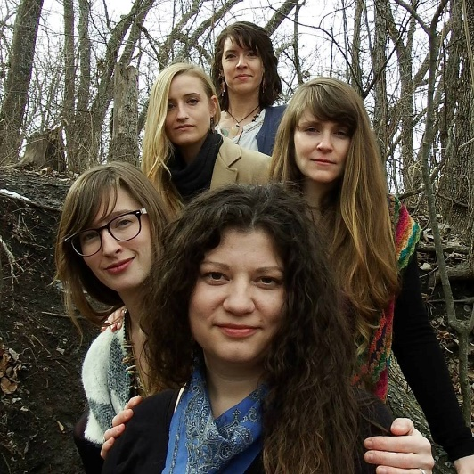
Chilocco - song lyrics
The Skirts (front to back): Elexa Dawson, Rachel Allai, Sarah Bays, Emily Wilson, Melissa Tastove
from The Skirts album- Many Moons

LISTEN to the song at: https://www.youtube.com/watch?v=PA-2l-DT3Rg
Oklahoma territory,
A wagon train from Blackwell come.
One more stop before the Kansas border line
Where we will live four years like orphan sons.
​
There's more they say that they must teach us.
We've many new ways of life to learn.
Nani mina Os cannot lead us,
Chemokman's living they must earn.
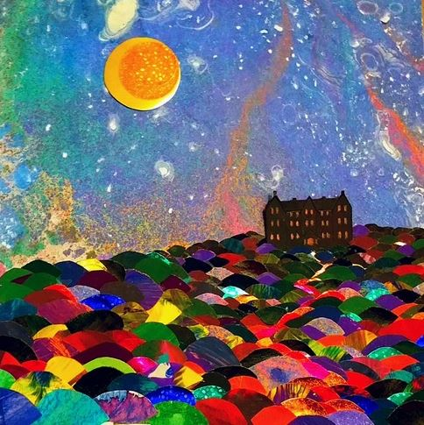
​Rock walls and wooden floors in Chilocco
Depiction of Chilocco Boarding School On Many Moons album cover, created by Skirts band member Emily Wilson.
Will not contain the wildness in my spirit in my soul.
No rest ntowema tonight.
Awake the vision of prairie lights.
​So, I will tend tomorrow's gardens
And I will feed tomorrow's stock.
But, the ways and the stories of my yesterday,
I once knew well but I forgot.

Rock walls and wooden floors in Chilocco
Will not contain the wildness in my spirit in my soul.
No rest ntowema tonight.
Awake the vision of prairie lights.

Way - Hah- Way - Hah - Yah - Hey - Yoh
Translations from Potawatomi:
- Nani mina os - ma and pa
- Chemokman - long knife, also white man
- Ntowema - brother

