RENE AUGUSTE CHOUTEAU (1749-1825) & JOHN PIERRE CHOUTEAU (1758-1849)
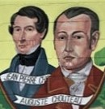
These two brothers became successful fur traders, businessmen, and government officials, developing strong ties with the Osage Indians and helping to found the city of St. Louis in 1764.
They were both born in New Orleans to a French trading family, and came to St. Louis in their youth, establishing the first trading center there in 1674.
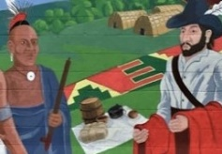
The Osage Indians controlled large areas of land, including Missouri, plentiful with fur-bearing animals such as deer, beaver, and bear. There was a big market for these pelts (furs) in Europe. The French had muskets, knives, kettles, blankets, ribbons and other imported goods.
This trading was hard work. The Indians brought furs and hides in packs weighing about 100 pounds each. The French traders had to paddle their trade goods upstream 1,200 miles against the current of the Mississippi river. (The return trip downstream for the French was relatively easy.)
Since the valuable furs they sought were obtained by trade with the Indians, Pierre and Auguste learned the importance of having good relations with the Indian tribes that supplied their furs, particularly the powerful Osage tribe. This was the key to their financial success.
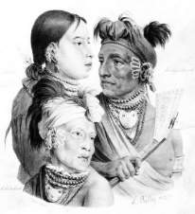
Auguste and Pierre became students of Indian culture. They were respectful of tribal customs and developed a reputation for being honest and fair. The Chouteaus were also known for providing a variety of high-quality goods to trade with tribes that supplied them with furs. This reputation helped the Chouteaus succeed despite competition from other traders. Pierre and Auguste also lived among the Osage at times, having children with Osage Indian wives. Jean Pierre’s oldest son, Auguste Pierre Chouteau, later became an influential trader in the Three Forks region of Oklahoma*.
In return for Chouteaus building a fort in the village of the Great Osage southwest of St. Louis, the Spanish gave them a monopoly on trade from 1794-1802. The Osages were glad to have a trading post near them with access to new manufactured products.
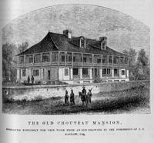
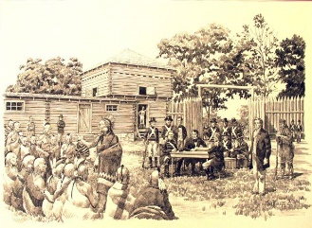
Pierre was later named the head Indian agent for Upper Louisiana. As US Indian agent, Pierre Chouteau negotiated the Osage Treaty of 1808 on behalf of the United States government, by which the Osage ceded huge portions of their lands in present-day Missouri and Arkansas (52,480,000 acres).
The Chouteaus lived out the rest of their lives in the trading center of St. Louis, having accumulated great wealth as pioneers in the fur trade and subsequent ventures in real estate, banking, iron manufacturing, railroads, mining, and utilities.
See slide show of related images: http://www.stltoday.com/news/local/govt-and-politics/look-back-osage-indians-pushed-out-by-arriving-americans-in/article_f7721ac6-78dc-5976-b644-63b6c1e44d5e.html
Read more about it:
- Notebook of Historic Missourians: https://shsmo.org/historicmissourians/name/c/chouteau/
- Chouteau Family - Encyclopedia of Oklahoma: http://www.okhistory.org/publications/enc/entry.php?entry=CH056
- *On oldest son of Jean Pierre Chouteau: Auguste Pierre Chouteau (1786-1838) - influential trader in Oklahoma http://www.okhistory.org/publications/enc/entry.php?entry=CH057
- Story of the Fur Trade at St. Louis: http://www.stltoday.com/news/local/state-and-regional/look-back-fur-trade-establishes-st-louis-finances-its-growth/article_9ab837a8-02dd-5cc2-9c0a-91d34b7df4b5.html

