OSAGE & FRENCH TRADING MURAL - FACT SHEET 6-12
Cuba, Missouri displays two large works of public art which are a tribute to the Osage people who once lived in Missouri. This art demonstrates that community’s respect and appreciation of the heritage of the Osage. What are these two art works, and what can we learn from them?
- “Meeting in Missouri” Mural
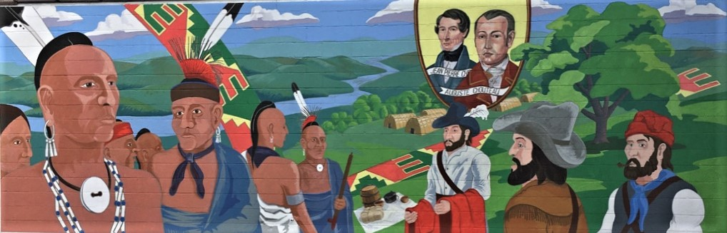
- “Meeting in Missouri” mural is at 108 S. Buchanan St, Cuba, Missouri 65453, along old Route 66 - now West Washington St. This was a route once traveled by the Osage in trading with the French. Cuba is known as the “Route 66 Mural City.” This is the 14th mural of the community betterment organization, “Viva Cuba.”
Background Story - on Plaque near “Meeting in Missouri” mural:
The Osage (Wa-zha-zhe) tribe were early inhabitants of the Missouri region. Their villages were located along the Osage and other Missouri rivers. French explorers first made contact with the Osage in the 1670s. At that time, the Osage were the most powerful tribe in the region.
The French cultivated strong trade relations with the Osage lasting into the early 19th century. The Chouteau family figured early in Missouri history by establishing a flourishing commerce relationship. The Osage referred to St. Louis as Chouteau’s town, and traded furs at the early settlement for European goods.
Trails and trade routes, established by the early Native Americans in our area, eventually became (old) Route 66 and Interstate-44, the roads that we travel on today.
INTERPRETING THE MURAL - “Meeting in Missouri”
What is a “mural”? A large-scale painting that is painted directly on a wall
What is the purpose of a public mural? To be a memorial (a permanent remembrance) of an event or person.
Who is the artist who painted this mural? Osage artist Norman Akers designed and painted this scene. Learn more about his art at http://normanakers.com/home.html
What is the title of the mural? “Meeting in Missouri”
INTERPRETING DETAILS - every element in the mural is there for a reason. What can we learn from the details in the mural?
What is the mural’s SUBJECT/THEME? A trade meeting - trading furs for manufactured goods (See related LESSON: EVALUATE EFFECT OF FUR TRADE)
Setting: WHEN did they meet? The scene portrays trading activities from 1780 - 1810 - these trading meetings happened many times
Setting: WHERE did they meet? The landscape shown is a river scene in Missouri surrounded by hilly prairie and woodlands. This was ancestral land of the Osage Indians. For the French traders, rivers were the best form of transportation of goods through the wilderness.
Characters: WHO are the PEOPLE meeting in the scene?
- (at left) Osage Indians who have traveled to meet with trade representatives and conduct trading business.
- (at right) 3 traders: These are French representatives from the Chouteau trading enterprise, probably coming from the primary trading center St. Louis. They are portrayed with French beret, beards, and European clothing mixed with buckskin frontier clothing.
- (in oval) Auguste & Pierre Chouteau - founders and owners of the flourishing fur trading enterprise between the French and the Osage. Also founders of St. Louis. (See related LESSON: CHOUTEAUS - BIOGRAPHY)
WHAT is on the blanket in the middle? These are the purpose of the meeting: items of trade
- Wrapped large tied bundle - possibly blankets going to the Osage, or furs going from the Osage to the French
- Barrel - various trade goods
- Cast Iron pot and Brass pots - valued by Osage
Also note red blankets being offered.
What are the colorful strips interwoven into the landscape?
- This is Osage ribbonwork, shown in the classic “forked: design. They represent this beautiful traditional Osage art form developed from French trade of satin ribbon. (p. 166 Bailey & Swan) (See related LESSON: OSAGE RIBBONWORK)
What are the structures in the background on the right?
- These are Osage Lodges - Long houses covered with woven reed mats. They represent that Missouri was the land of the Osage people. (See related LESSON: OSAGE LODGES)
Background - PRIMARY SOURCES: Read these description written at the time describing the appearance of Osage warriors
By author Washington Irving (1832):
“[The Osage are] stately fellows; stern and simple in garb and aspect. They wore no ornaments; their dress consisted merely of blankets, leathern leggings and moccasins. Their heads were bare; their hair was cropped close, except a bristling ridge on the top, like the crest of a helmet, with a long scalp-lock hanging behind. They had ﬁne Roman countenances, and broad, deep chests; and, as they generally wore their blankets wrapped round their loins, so as to leave the bust and arms bare, they looked like so many noble bronze ﬁgures. The Osages are the ﬁnest looking Indians I have ever seen in the West.”
By artist George Catlin (1845): “the tallest race of men in North America either red or white skin, many of them six and a half, and others seven feet.”
What can we learn about the Osage culture from the mural’s depiction of the Osage men? Find these details in the mural.
Find 4 items which involved trade goods from the French.
- Osage men are clean shaven (in contrast to bearded French). The Osage often believed Europeans fell short in their personal grooming habits.
- Roach haircut - on figure with no headdress. Men wore their hair in a roach on top, sides shaved, and a long “tail” of hair grew on the back side of the roach (p. 209 Burns)
- Roach (Headdress) Roach headdress was made from rows of turkey beard or long guide hair from porcupines, attached to flexible base, with row of shorter hair from a deer tail dyed red. The “spreader” was made of horn or bone and later silver - pushes the stiff hairs into a vertical stance and allows it to be attached to wearer, has socket for single Golden Eagle feather. Men would braid very top of their roached hair and use this to attach roach spreader (p. 166 Bailey & Swan)
- Single Golden Eagle Tail feather (p. 166 Bailey & Swan)
- Ball & Cone Earrings: worn today by In-Lon-Schka dancers, a favorite with both sexes (p. 167 Bailey & Swan). Made of German silver, nickel, or tin.
- Hairpipe bone necklace (similar to p. 20 Bailey & Swan necklace, though that of traded saltwater shell wampum bead, this of bone).
- Shell Disk Gorget - wah-sha-she-skah, carved from fresh-water mussel, representing Grandfather the Sun - worn by Star-That-Travels a/k/a Bacon Rind (Mathews p. 779).
- Otter-fur Turban - “Beaver or Otter Bandeau” (Mathews p. 737).
- German Silver Armbands - originally used as a form of armor to deflect blows of the enemy; later as ornamentation (Bailey & Swan p 171).
- Blankets - made of wool, valued for trade. “Woolen trade blankets were softer and easier to wear than robes made of buffalo hides, or bearskins, so blankets replaced them as wearing apparel. However, since the early trade blankets were solid colors (shown here in red and blue), the Osage eventually began to decorate them” - leading to the ribbon work art form (Bailey & Swan 8). Later after all moved to the reservation (in early 1870’s) and on into 1900’s, Osage people who were keeping to traditional ways would continue to wear these blankets.
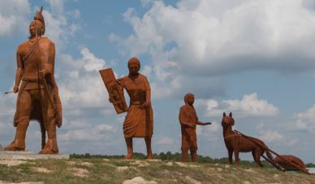
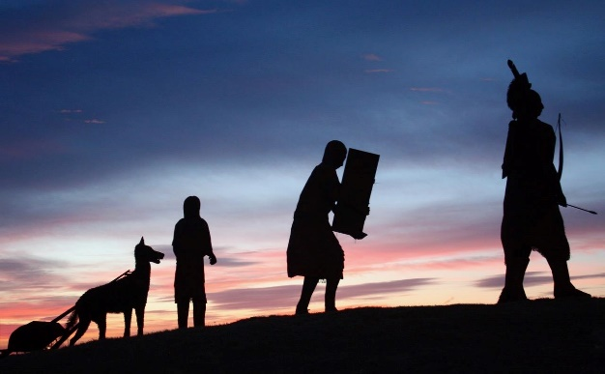
- Scarf - Made of silk. Common trade item. (p. 172 Bailey and Swan also show “slides”).
- “Osage Trail” Sculpture
Also in Cuba, Missouri is another work of art dedicated to the Osage and their early trails which later became the highways of today.
The “Osage Trail” Sculpture is located at the Cuba, Missouri Visitor’s Center on Interstate Highway-44, which originally was an Osage trail. This is a 35-foot tall steel sculpture, created by artists Glen & Curtis Tutterrow. It portrays an Osage family traveling west along this Osage Trail. Learn about the sculpture project at: http://www.osagetraillegacy.com/ (scroll down).
HISTORY from the Osage Trail Legacy website: http://www.osagetraillegacy.com/history
“At the dawn of this nation’s expansion, this trail carried furs and lead ore to St. Louis and brought back food, clothing, and supplies from St. Louis to the rural areas of Southwest Missouri.
But this trail carried more than merchandise, it also carried ideas and innovation. It carried the ideas that would form a young, energetic, and growing republic of the early 1800’s. But, who were these trail blazers and what happened to them? …
The Osage, throughout history, were recognized for the fierce defense of their families, their land, and their freedom. Unfortunately for this commitment they paid the ultimate price; they lost everything they had dedicated in the land of their ancestors. They lost their home called Missouri.
Missouri Governor Clark said that the 1825 Treaty, which removed the Osage from Missouri, was the hardest treaty he had ever made, and he feared he might be damned in the hereafter for his part in the agreement.

