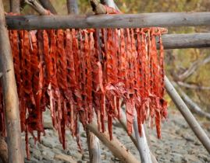
FACTSHEET - Early Osage Food Preservation*
- Buffalo short ribs were flattened and sewn together into a large sheet with bark thread and thrown over racks to dry. (Burns 211)
- Long strips of buffalo muscle were dried, sometimes braided together, over fires. (Burns 211)
- Once dried, meat was saturated in fat and stored in parfleches, where it could keep up to 2-3 years. (Burns 211)
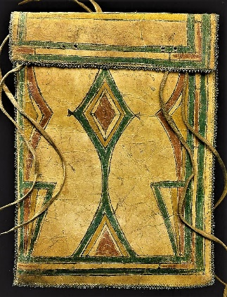
- A parfleche was a rawhide container used to store precious items as well as everyday prepared foods including dried meat, pumpkin strips, dried persimmons and corn. To make the parfleche, the hide was scraped clean of all hair and flesh and then dried. It was then soaked in water to soften and mold it into a permanent rectangular envelope-type form, laced closed with rawhide thongs. These were decorated with personal designs to designate the owner. (Bailey 84) (See Art Lesson - Parfleches)
- Osage made a sausage of buffalo intestine stuffed with thin strips of meat and broiled on charcoal embers. (Burns 211)
- Pemmican was made of pulverized dried buffalo meat, berries, nuts, marrow and suet - tamped tightly into a deer skin bag with no air space. It would keep for several years and could be eaten cooked or uncooked. (Burns 211)
- Stanica was made of persimmon fruit with seeds removed, then dried on a wooden paddle into fruit “leather” which could be braided and stored in a parfleche. (Burns 212)
- Bone marrow and buffalo fat were used instead of butter. These were kept in doeskin sacks. (Burns 211)
- Fry bread was cooked in boiling fat from the buffalo or bear. (Burns 211)
- Although women did by far the most cooking, “The Osages had a class of men who served as chefs or cooks, devoting themselves to the culinary art, to preparing and presiding over formal feasts…These unusual men were called marmitons by the French.” (Burns 207)

SOURCES: Bailey, Garrick Alan and Daniel C. Swan, John W. Nunley, and E. Sean Standing Bear. Art of the Osage. Seattle: St. Louis Art Museum in association with University of Washington Press, 2004. Burns, Louis F. History of the Osage People. Tuscaloosa: University of Alabama Press, 2004. Compiled 2018.

