OSAGE LODGES & VILLAGES - FACT SHEET
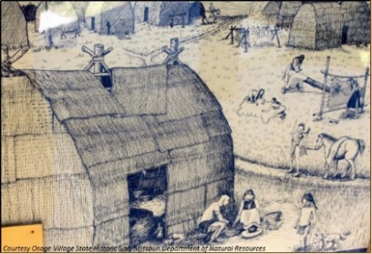
LODGES: What were the main dwellings of the Osage CALLED? A “lodge” (sometimes also known as the “long-house” or “wa-sha-tsi”)
What SHAPE were they? Oval with domed roof
What SIZE were they? Vary from 7-20 feet wide, 15-50 feet long, and 4-20 feet high. Depending on the number and size of families occupying them, they could be up to 100 feet long.
HOW MANY PEOPLE would live in the lodge? 10-20 people. Multiple families would live in a single lodge. Since large families were highly valued, potentially large numbers of people could reside in one lodge.
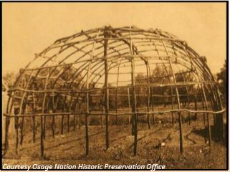
What were the lodges MADE OUT OF?
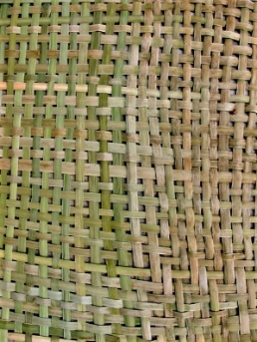
Frame - made of poles stuck into the ground, bent over, and tied together to form a domed frame, with horizontal poles on sides. What type of wood? Whatever was available, possibly hickory - a hard wood for the ridge pole, pliable young green wood from saplings, such as willow, to bend out for walls. Binding - How did they tie the frame poles together? With cordage made from animal sinew, plant fiber such as green bark strips from the poles themselves, buffalo hair rope Covering - woven reed mats (i.e. cattail), sheets of bark, hides, (later canvas)
What type of ARCHITECTURAL STRUCTURE is this? Osage lodges were a “bent frame” structure (in contrast to the plains tribes’ teepees which are a conical “joined frame” structure) (Nabokov 16)
What were the STEPS in the construction process?
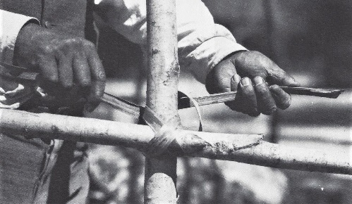
- Construct ridge pole (hung across top between 2 poles)
- Build frame around ridge pole: stick side poles into ground vertically, bend, and tie onto ridge pole & frame
- Wrap and tie smaller poles horizontally around the edge of frame
- Attach covering
What was the “FLOOR PLAN” - doors, fireplace, furniture, etc.?
- Common lodges had one door on east side. Chiefs’ lodges had a door on east side and on west side.
- Two internal fireplaces - for cooking and heat - with holes in the roof overhead
- For furnishings, they had low benches (2’ high) along the walls - for seating and sleeping
What kind of OTHER FURNISHINGS AND OBJECTS would be in the lodges?
- Floors covered with woven mats
- Hides and robes on benches & floors - for seating and sleeping
- Wooden bowls, spoons carved from wood or buffalo horn
- Pottery jars and bowls, plaited basketry - later, brass buckets

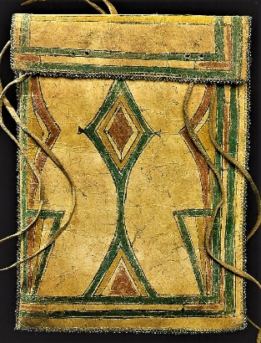
- Hung on walls: leather or woven bags of small objects or sacred items
- At ends or under benches: stored items such as food or clothing in larger rawhide bags (see at right: parfleche)
Were the Osage villages PERMANENT? The main villages were as permanent as fuel, water, game, sanitation, wild food plants, and tillage area allowed. Over the years as these waned, the village would have to eventually move.
What types of dwellings were used DURING BUFFALO HUNTS to the west?
Pack up main lodges: First, they would partially take down their permanent lodges - remove and store the coverings - leaving only pole frameworks standing. Some items were bundled and placed in trees or in pits.
- Wigwams (smaller, semi-permanent, trail-side lodges): every 10-12 miles on well-defined trails to the buffalo plains were regularly-used, named campsites with pole frames standing from earlier trips. They were around 15 ft. long, 7 ft. wide, and 4-5 ft. high. Mats & hides might be brought along; additional covering could include twigs, cane, moss and grasses.
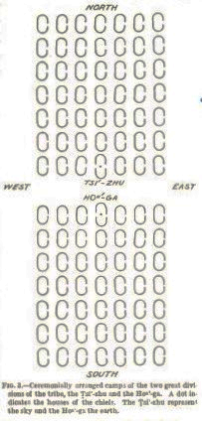
VILLAGES: How were the lodges laid out within the village? These homes were constructed within special locations in orderly communities with a specific layout - reflecting the social structure of the entire group: Two main divisions: Sky People - Tsi-zhu (9 clans) and Earth People - Hon-ga (15 clans). Osage would marry someone from the other division. A “clan” is a kinship group (related families). Both villages and homes were laid out along an east-west axis. Clan leaders would work with families to locate their designated spot.
Early - Gentile Division Chief Villages: The villages were oriented to follow the path of the sun - with a central road running east and west.
- Tsi-zhu (Sky) lived on north side and Hon-ga (Earth) lived on south side, with their chief’s lodge at the center by the road and lodges of each clan grouped in their own areas behind.

- Later - Band Villages: Around 1800, the Division Chiefs started living in separate villages: Sky Chief with the White Hair bands and Earth Chief with the Claremore bands. These villages varied greatly in size.
What OTHER STRUCTURES might be found in the villages? House of Mystery - ceremonial lodge used by priests. Sweat Lodge - small domed lodge used as part of ceremonies and for purification of the individual
SOURCES: Bailey, Garrick Alan and Daniel C. Swan, John W. Nunley, and E. Sean Standing Bear. Art of the Osage. Seattle: St. Louis Art Museum in association with University of Washington Press, 2004 (pp 52-54). Burns, Louis F. History of the Osage People. Tuscaloosa: University of Alabama Press, 2004 (pp 42-43). LaFlesche, Francis, “The Osage Tribe: Rite of the Chiefs, Sayings of the Ancient Men,” Thirty-Sixth Annual Report of the Bureau of American Ethnology (1914-15), Washington, D.C. Nabokov, Peter and Robert Easton. Native American Architecture. New York: Oxford University Press, 1989. Osage Culture Traveling Trunk learning program (2010), Missouri State University, Osage Nation, History Museum on Square. Osage Nation Historic Preservation Office. Compiled 2018.

