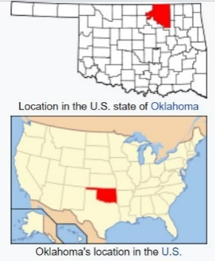
OSAGE LANDS & MINERALS - 1872 to TODAY
FACT SHEET
Since their beginning, the Osage people have been connected to the land: physically, culturally, and spiritually. Despite losing huge amounts of land in the last two centuries, their connection to the land remains alive and powerful.
RESERVATION IN OKLAHOMA
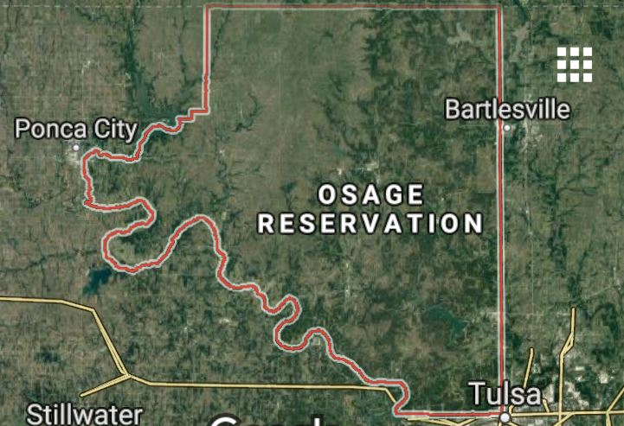
In 1872, the Osage made their final move, to what would become the present home of their nation: the Osage Reservation - 1.5 million acres in northeast Oklahoma. This was land they purchased from the Cherokee with funds from sale of their land in Kansas. This area is the same as Osage County, Oklahoma.
The eastern part of the reservation was wooded, with rock-ribbed hills and open meadows (Cross Timbers eco-region). The western part was rolling tallgrass prairie - the Flint Hills eco-region. (See Map - Eco-systems of Osage Reservation.)
After having their lands repeatedly stolen by white squatter-farmers in the past, the Osage felt this area was safer since whites thought it too rocky and hilly for cultivation.
ALLOTMENT and MINERAL RIGHTS
In the late 1800’s, the federal government wanted Native Americans to assimilate - give up their way of life and blend in to white society. One way to accomplish this was the Dawes Act in 1887 which divided up the communally-owned reservations into privately-owned allotments - a share or piece of land, with “surplus” land sold to non-natives.
For most tribes, this would “end the old communal way of life and turn American Indians into private property owners” - and make it possible for whites to buy Indian land (Grann 49). Another reason for allotment was the U.S. wanted to turn the Indian Territories into the state of Oklahoma, but to do this, all land had to be individually owned (Powell 56).
However, because the Osage had purchased their own reservation land, they were exempt from these earlier allotments under the Dawes Act. Under the wise leadership of Chief James Bigheart, the Osage insisted on the following unique provisions in their Osage Allotment Act in 1906:
- Larger Allotments: Instead of allotting just 160 acres to each person and selling the rest, as other tribes had been forced to do, the Osage allotted all their reservation land to their people. This gave 657 acres each to the 2,229 registered Osage (Grann 52).

- Reserved Communal Mineral rights:

- They “reserved” - held back from allotment - their mineral rights: the right to mine or produce oil and gas, rocks, and minerals from under the ground was not allotted, and so was never lost.

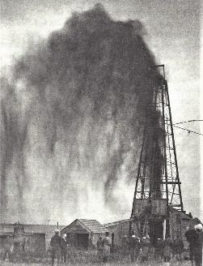
- They retained communal ownership of these reserved mineral rights, so all subsurface minerals belonged to the entire tribe instead of individuals. Instead of leaving to chance who might get rich later from oil and gas being found on their particular allotment, all tribespeople share equally in any mineral wealth (Wilson 62).

Each received a “headright” - right to a share of the whole mineral interest (oil) income - which could be passed on from generation to generation.
Reserving the minerals eventually resulted in the Osage becoming some of the wealthiest people in America during the 1920’s peak production of the Osage oil fields, among the largest in the world. (Oil income since that time has diminished considerably.)
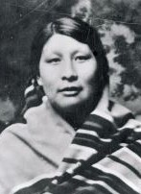
Although the oil boom reversed the economic misfortune of the Osage, it also resulted in immense suffering during the 1920’s “Osage Reign of Terror.” Some unscrupulous non-natives cheated and stole from the Osage by being appointed their “legal guardians” and then embezzling their income.
Rita Smith -Murder victim
Others attempted to access Osage wealth by marrying into families with oil income. Some then actually murdered their own family members to inherit headrights. Estimated numbers of Osage murder victims ranges from 25 into the hundreds though few prosecutions resulted.
David Grann’s recent best-selling Killers of the Flower Moon brought these injustices to national attention. [See in-depth Lesson: “Reign of Terror: the Osage Indian Murders”]
Today, the Osage mineral rights are held in trust and managed by the Osage Minerals Council. See https://www.osagenation-nsn.gov/frequently-asked-questions
SOURCES: Bailey, Garrick Alan and Daniel C. Swan, John W. Nunley, and E. Sean Standing Bear. Art of the Osage. Seattle: St. Louis Art Museum in association with University of Washington Press, 2004. Grann, David Killers of the Flower Moon: The Osage Murders and the Birth of the FBI. New York: Doubleday, 2017. Wilson, Terry P. The Osage. Indians of North American Series. New York: Chelsea House Publ., 1988. Compiled 2018.

