MYTH vs. REALITY - Little House on the Prairie
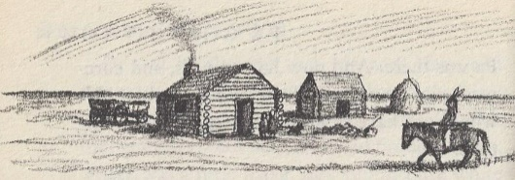
The Laura Ingalls Wilder story, Little House on the Prairie, is beloved by many readers. However, to the Osage people who know the tragic truth behind the story, it is inaccurate and insulting, attempting to romanticize the actions of people who stole their land and tried to destroy their way of life.
Granted, history is always problematic and perspectives change over time. Wilder was writing in the 1930’s when sensitivity to racial stereotypes was low, and she understandably attempts to paint a positive picture of her family. She does expose the genocidal racism of the day by somewhat negatively portraying characters who say, “The only good Indian is a dead Indian.” [Genocide is the deliberate killing of a large group of people (ethnic, national, racial, or religious).]
Nevertheless, Wilder’s fundamental narrative violates basic standards of truth by portraying the Osage Indians as intruders on the Ingalls’ claim, as critic Francis W. Kaye points out:
[The story] is framed in a way that leads the reader to feel that the Ingalls are in the right, but legally and by right of occupancy, it is the Osages who are the owners, and the settlers who are the unwelcome and threatening intruders. (p. 136)
Standard Frontier Myth: Without substantial background knowledge on this issue, many readers would accept the customary myth Wilder presents of her family’s part in frontier settlement, as summarized by Kaye:
A loving family of white settlers bravely sets out to establish a home for themselves. After many difficulties, much ingenuity, and with the cooperation of helpful neighbors, they establish an idyllic and isolated small farm. They survive the threat of unfriendly Indians… and witness the departure of the Indians from the district. Their going is sad but necessary if settlers are to make homes and change the prairie from lonely grassland to grain that will feed multitudes. The settlers' system of using the land to support many people is superior to the Osages' system of neglecting the land during the growing season to go on buffalo hunts. (133)
Let’s take the myth apart and compare it to reality:
- Sets out to establish a [presumably legal] home: In reality, Wilder’s father set out to “establish a home” by building it and knowingly trespassing on land belonging to the Osage Indians - an illegal act, i.e. a crime. He never files a claim on the property because it is not legal. He even admits this several times this in the book, saying they settled there because he thinks the government will eventually make the Osage move if there are enough settlers illegally taking their land, and he wants to be one of the first so he can get the best land (p. 47). He openly states that his goal is to contribute to and profit from the Osages’ downfall.

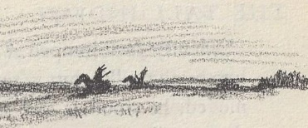
- Idyllic and isolated small farm: The Ingalls’ home is not “isolated.” It is in occupied lands, right next to an Osage Indian trail and camp. Wilder implies that the Osage somehow simply don’t count in the big picture when she describes “a pasture that stretched much farther than a man could see, and there were no settlers. Only Indians lived there” (p. 2). These “only Indians” of course were the actual owners of the land.

- Indians’ neglecting the land: The Osage encampment near the Ingalls was empty and not in use when the Ingalls arrived since the Osage were away on their semi-annual buffalo hunt. However, rather than “neglecting the land,” this rotation was sustainable and in harmony with the natural resources of the prairie. In contrast, by deliberately overhunting of the buffalo into near-extinction, the whites ended this way of life for the Indians. They replaced it with farming and permanent settlement, resulting in loss of 96% of the tallgrass prairie ecosystem.

- Feed multitudes [but starve Indians]: In truth, Pa spends much of his time hunting, not farming. In this, he is in direct competition with the Osage who now relied on local game for survival and were starving due to the influxes of whites taking their game, burning their crops, and stealing their livestock. Though initially game was abundant, the impact of 12,000-15,000 white squatters soon took its toll (Kay 130). Every animal Pa kills is taking from the dwindling food supply of the Osage people. Laura does not explain that when the Osage come to the Ingalls’ home for food, it’s because they were starving and rightfully collecting very minimal “rent” in the form of food. However, she does notice how thin the Osage are. While the Osage would have been within their rights to confiscate all the Ingalls’ property and evict them for trespassing, they instead took these mild steps of requesting only food.

- Threat of unfriendly Indians: Laura consistently describes the expressions of the Osage as villainous and threatening. Apparently, the Ingalls expected the Indians to be more friendly and gracious to the invaders stealing their land and food. Laura does not mention that the Osage themselves were repeatedly victims of violence from settlers. [See lesson reading “White Savagery”] While Pa does not directly endorse the genocidal talk of his neighbor Mr. Scott, “The only good Indian is a dead Indian,” Pa is willing to gain from these threats of extermination which will force the Indians to give up their land to settlers like him.

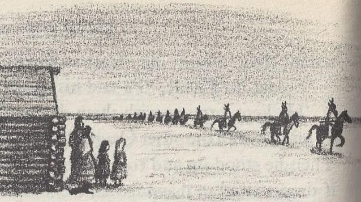
- Indians’ departure is sad but necessary: Saying the Osages’ departure is “necessary” is part of the white supremacist idea that Native Americans were less worthy and must surrender their land to Euro-American settlers. It implies the settlers’ decision to steal the land of others was inevitable, as if they couldn’t have actually obeyed the law, respected the Osage ownership, and instead made land claims where it was legal. In fact, the only “necessity” was self-imposed: the settlers’ selfish desire to take what was not theirs from a weakened and mistreated people whom they hoped would just disappear, at a time when actual genocide of native people was openly discussed and accepted.
The Aftermath - A Strong Osage Nation in Oklahoma Today:
The good news not related in Wilder’s story is the Osage “did not disappear from the face of the earth when they left Kansas in 1870.” In fact, through wise leadership and tenacity, they negotiated a favorable price for the sale of their Kansas land and used it to purchase their current reservation in northeast Oklahoma, with substantial funds leftover. Although the transition was extremely painful, and many more Osage perished in the early years, they have since “maintained themselves through booms and busts and today remain an influential people of Oklahoma.” (Kay 131)
Sources: Kay, Frances W. “Little Squatter on the Osage Diminished Reserve: Reading Laura Ingalls Wilder’s Kansas Indians.” University of Nebraska - Lincoln DigitalCommons@University of Nebraska - Lincoln, Center for Great Plains Quarterly Great Plains Studies, May 2000. Compiled 2018.

